May 3, 2026
- made a repository for the project.
  - I did this by following the project template from the SFML 2.6 website.

- To ensure compatibility across different platforms (mac/windows), I used CMake to compile.

- The link to the repository: https://github.com/jams385/Oasis-Repository
  - Terminal flow for github:
  - git add .
git commit -m "<name>”
git push

- I’m using the official SFML website as a guide: https://www.sfml-dev.org/tutorials/2.6/

  - I learned how to open a window using SFML 2.6
  - 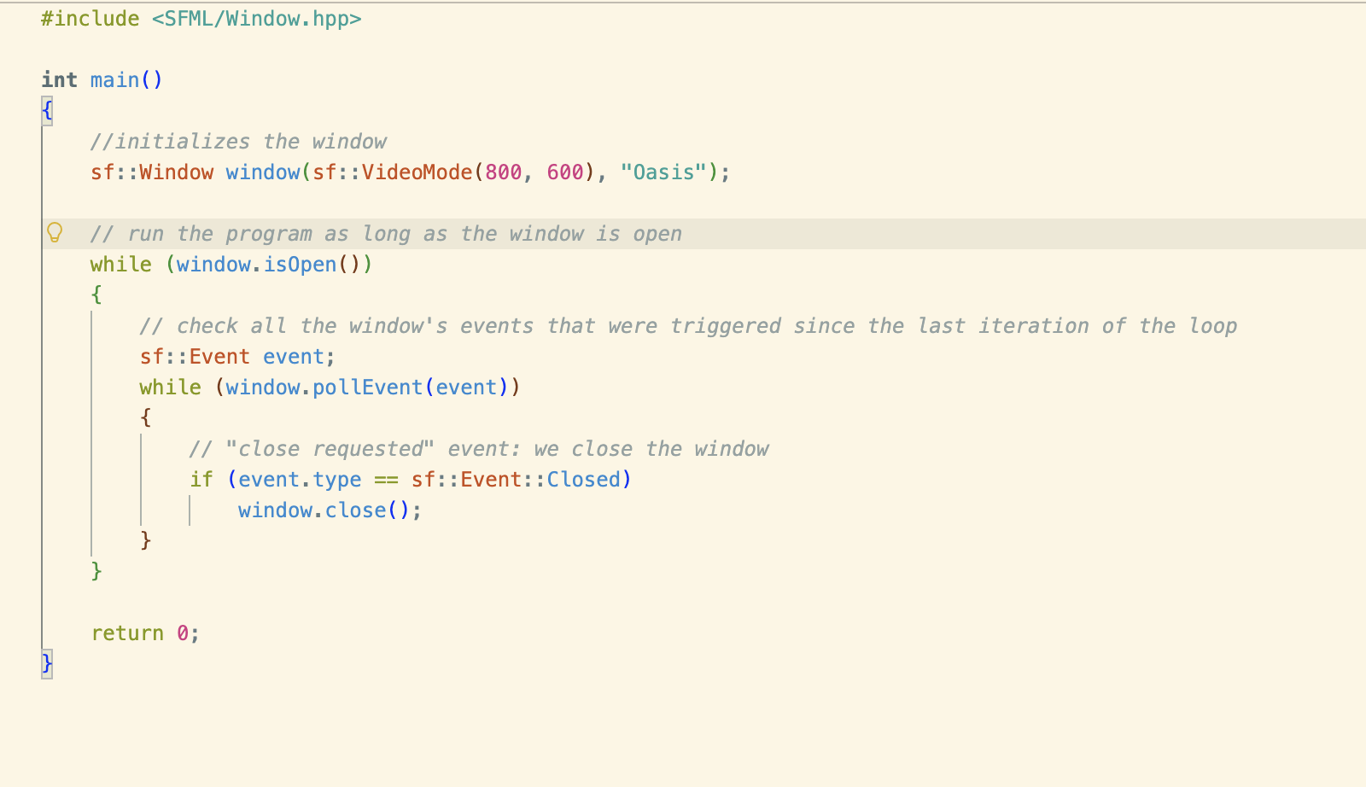
¡
- Made a blue circle shoot a red circle LOL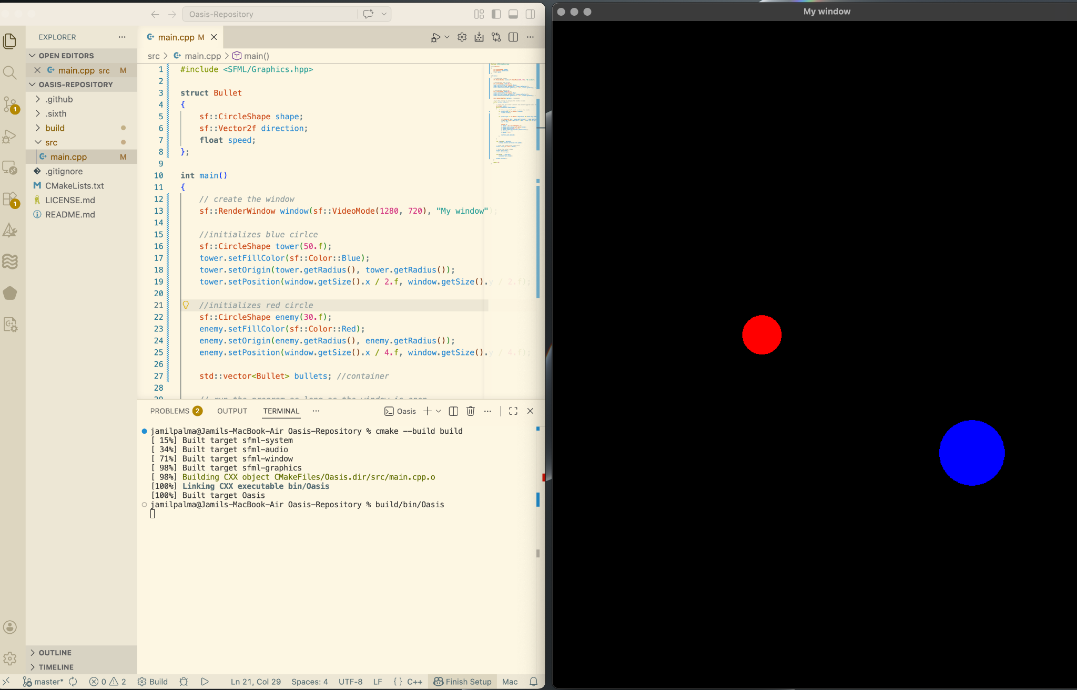
- So what I learned:
  - How to animate a “bullet”
    - Created struct named Bullet with values like shape, direction, and a float value for speed.
    - Vector2f? It’s a struct within the sfml library which stores an x and y value. So in this use case we made a variable called “direction” and this direction stores an x and y. So you can imagine it as “direction(x,y)”.
    - Vector is used in the main function inside the event loop.
      - If the player presses the space bar, a “bullet” is created and is launched towards the direction of the red circle. This is done by subtracting the enemy position from the tower position:

      - sf::Vector2f dir = enemy.getPosition() - tower.getPosition();
        - So “dir” represents an arrow pointing to the enemy.
      - Float len = std::sqrt(dir.x * dir.x + dir.y * dir.y);
        - Gets the distance formula which represents the distance from tower to enemy.

May 4, 2026
- Mostly just added things to improve the previous build.
  - Outer range circles
  - Moving enemies
  - Another shape, “cornucopia”, with a health bar.
  - Spawning enemies (although broken blepblep)

May 5: MENU + HUD
- With enough understanding, we’ve scrapped the previous build and we’re starting to formally work on the actual game.

- My goals for today are the following:
  - Create a Menu Screen
  - Create the playing environment
  - Create the HUD/UI

CREATING THE MENU SCREEN
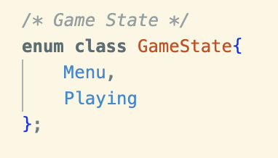
- Done through a class called “Game State”
- This allows us to set game states based on the user
Input
  - In future iterations, this will include “Pause”, “Inventory”, or smth like that.

EXPLAINING DELTA TIME AND THE CLOCK

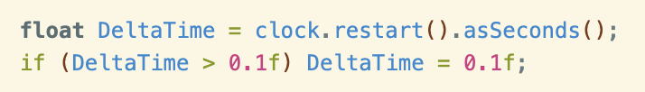
- After writing `int main()` there is a Clock variable named clock. When you assign a data type of “Clock” to a variable this variable will store float values that will keep increasing. This acts as a “clock” or a “timer” which will be helpful later down the road.
- In the Game Loop, we see this block of code.
  - clock.restart() = resets the clock to 0
  - asSeconds() = converts the float into seconds
  - DeltaTime receives the converted value
  - The if statement keeps the value of DeltaTime consistent as it loops. It makes sure that time elapses a consistent amount per iteration of the loop.

- Another important note is that the speed in which the program loops is controlled by the FPS Limit. In our game, the fps is set to 60 (window.setFramerateLimit(60)).

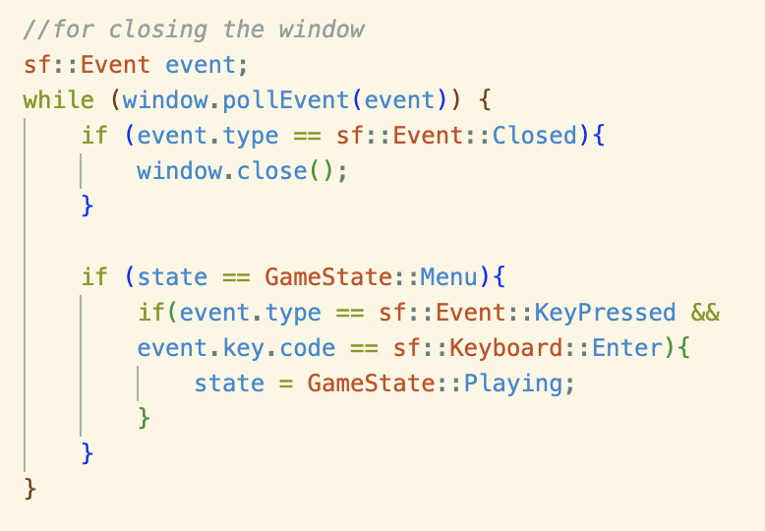
READING USER INPUT AND SWITCHING BETWEEN GAME STATES

- A variable with an Event date type stores information about ‘events’. For example: pressing a key, closing a window, etc.
- pollEvent(event) checks if something happens. If so it gives the data to the variable “event”. In this program, we use it to close the window. We also use it to change the game state from “Menu” to “Playing” when you press the “Enter” key.

DRAWING TEXTS
* Disclaimer: this is a self made implementation and I am fully aware that there are probably better and more scalable ways of implementing “text” editing.
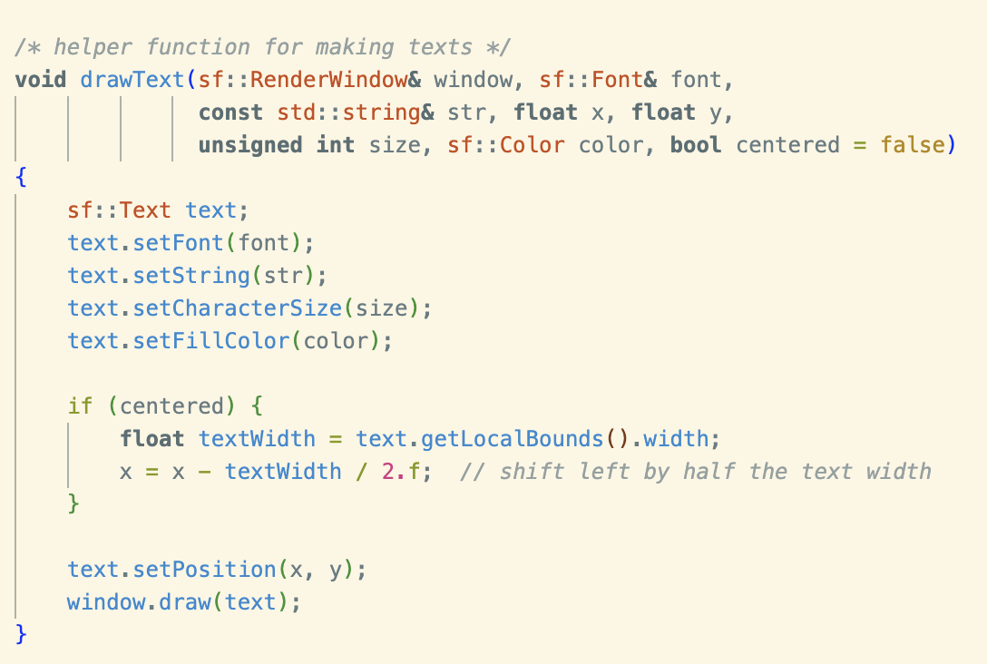
- In the main.cpp file, I've created a draw text function that takes multiple inputs and will help initialize the text that you want.
- Note, SFML makes it so that the origin point of the text is at the top left. The if statement makes it so that the origin is at the center. So, when we input a position the text’s midpoint will be the one in the position.

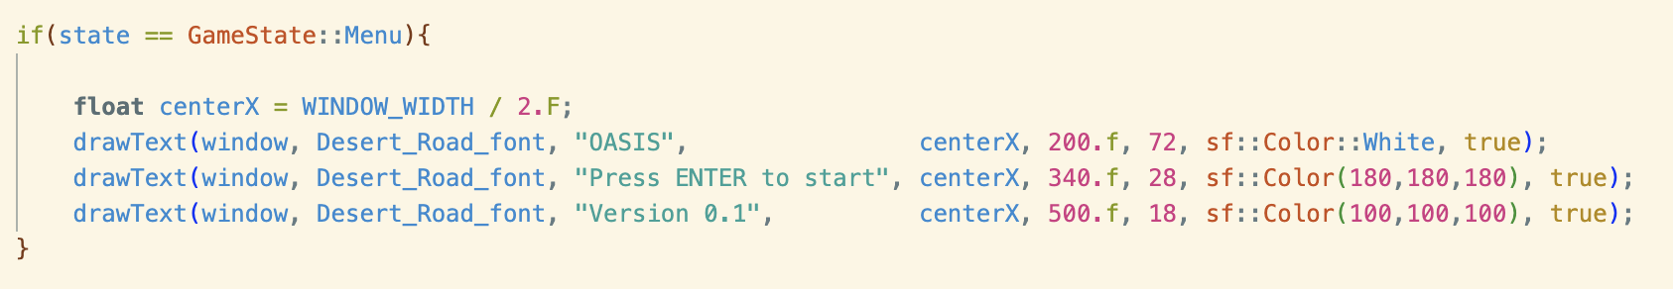

- These are texts in the menu screen. This is a great example of how the function is implemented in the main program ^^.

CREATING THE HUD
- The HUD is created through 3 things: the HUD.h, HUD.cpp, and the actual implementation on the main file.

HUD.h and HUD.cpp
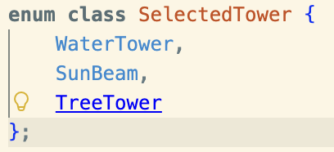
- These are the towers that the players can select.
- This will be used to get information about which tower the player is currently selecting.

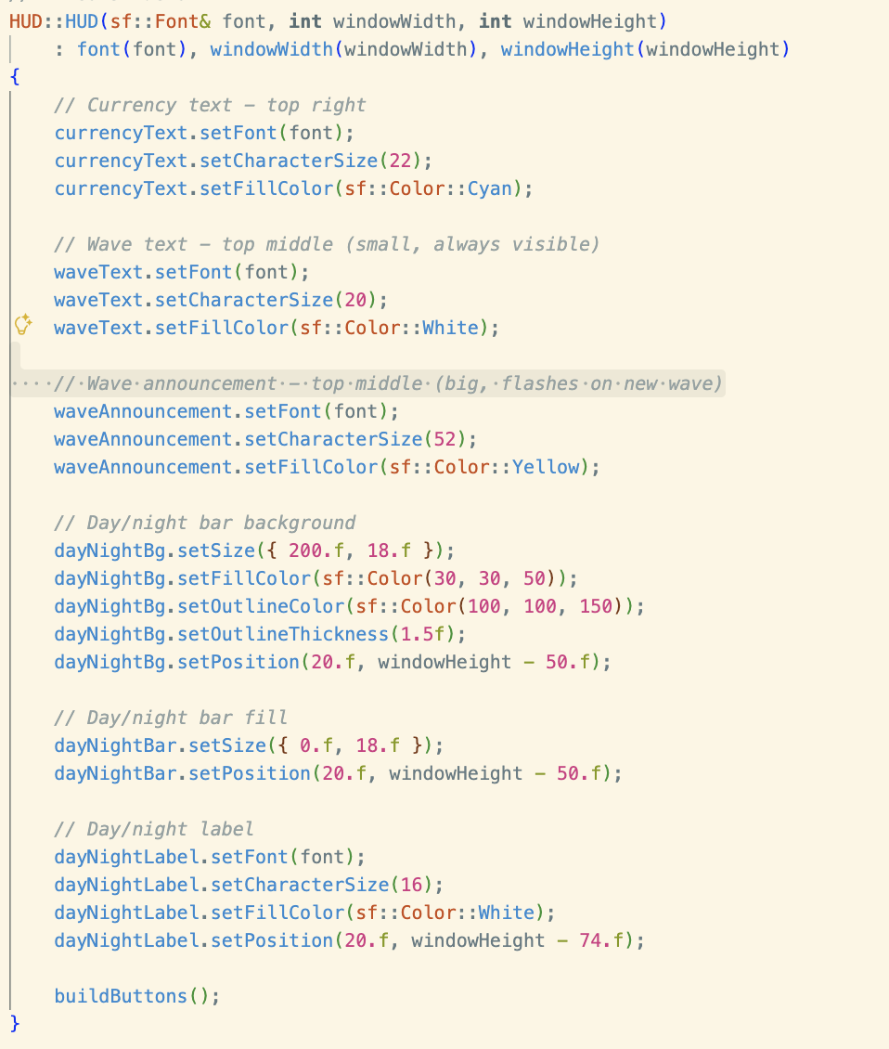
- Next is the HUD() function

- The function takes multiple values that correspond to different characteristics.
- These values are then used to initialize the different elements in the hud.
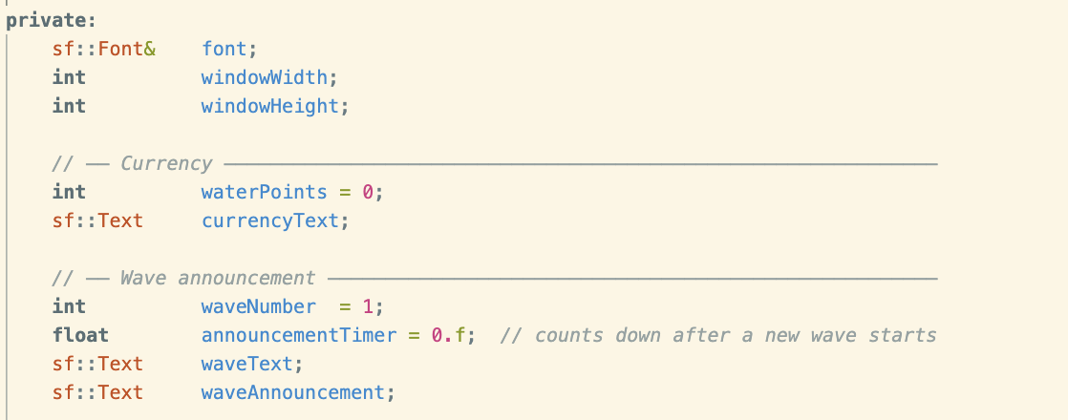
- Now, you might be wondering “Where are these variables like currencyText, waveText, and dayNightBg , coming from?”. These are variables that come from the HUD.h header that we created. Here’s a snippet of the code in hud.h:

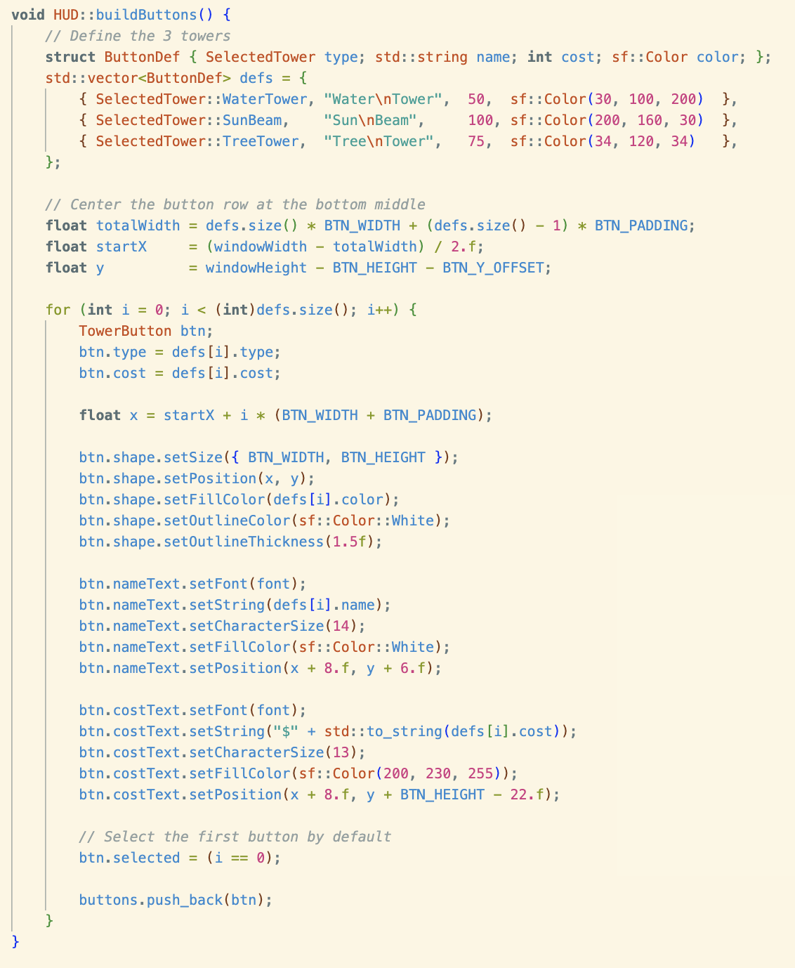
- buildButtons() Function
- First we define our 3 structures: type, name, cost, and color.

- Then, we center the row to the bottom middle.
- We use a for loop to initialize a button for each tower.
- Each button consists of the following:
  - Rectangle (visual)
  - Name (text)
  - Cost (text)
  - Type (text)
  - Selection State (for highlighting)

- buttons.push_back(btn); stores the current button’s characteristics to be used later.

- update() Function
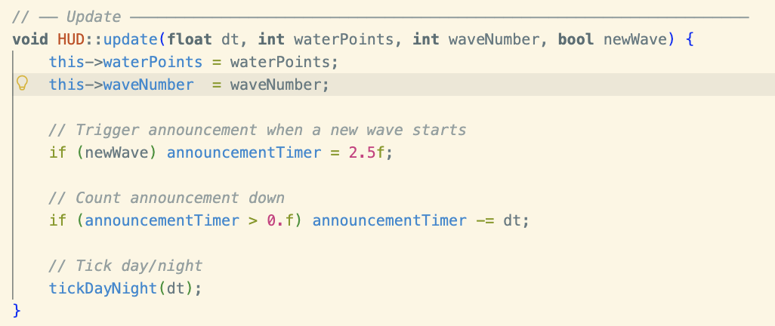
- Stores values and updates the timers.
- First, main.cpp has values for waterPoints and waveNumber. This is taken by the update function and updates the hud.

- tickDayNight() is a function that will be tackled next.

- tickDayNight()
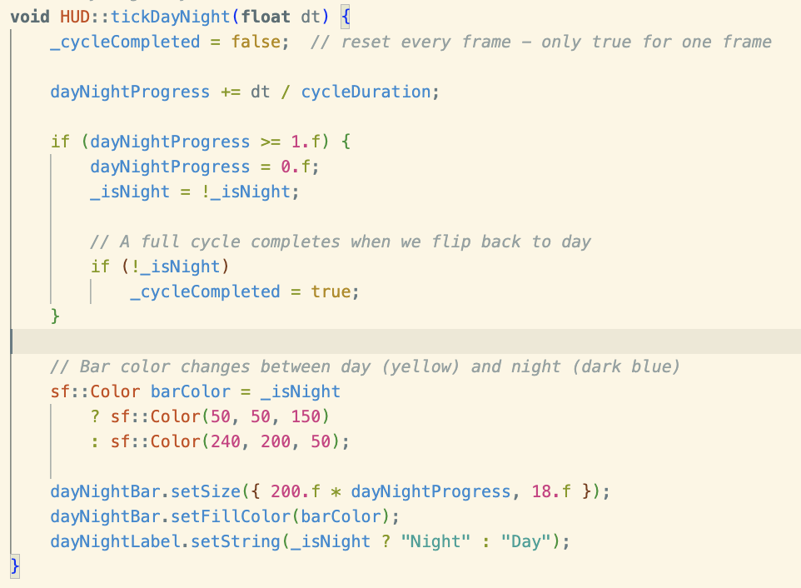
  - It is used as a progress bar for the day/night cycles.

- _cycleCompleted is a boolean variable that helps us switch from night and day.
- dayNightProgress helps in keeping the time between day and night consistent. cycleDuration can be edited in the HUD.h file.

- The if statement helps us convert from day and night.
- Then we add a bar and two colors to represent day and night.
- We “animate” the bar by multiplying the current “x” position to the dayNightProgress variable.

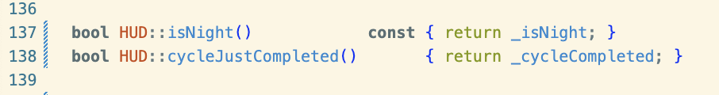
- Notice how we also used some boolean functions to check the day cycle and if the cycle is completed. This is where it is initialized.
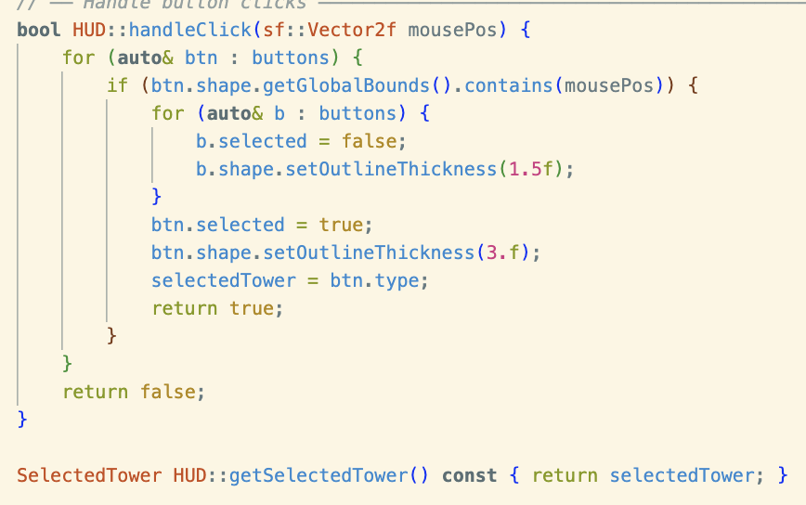
- handleClick()
- This boolean function tracks if the player clicked on the tower button. Then it highlights the button to signify that it has been clicked.
- It takes the position of where the mouse clicked and outputs “true” if a button was clicked and “false” if nothing was clicked.
- It does this by looping through each button.
- The if statement is a “collision check”, it checks if the GlobalBounds (a rectangle with a position and size) contains the “mouse position”.
- If MousePos is in the GlobalBounds, then that button is selected and gets highlighted. Do note that there is an inner for loop that checks for a previously selected button and unselects it before highlighting the newly selected button.

WOOOOOOOOOO OKAY!!!

- So after all that, we now get to draw the actual hud into the window. Well, at least make the functions that will draw these elements onto the window.
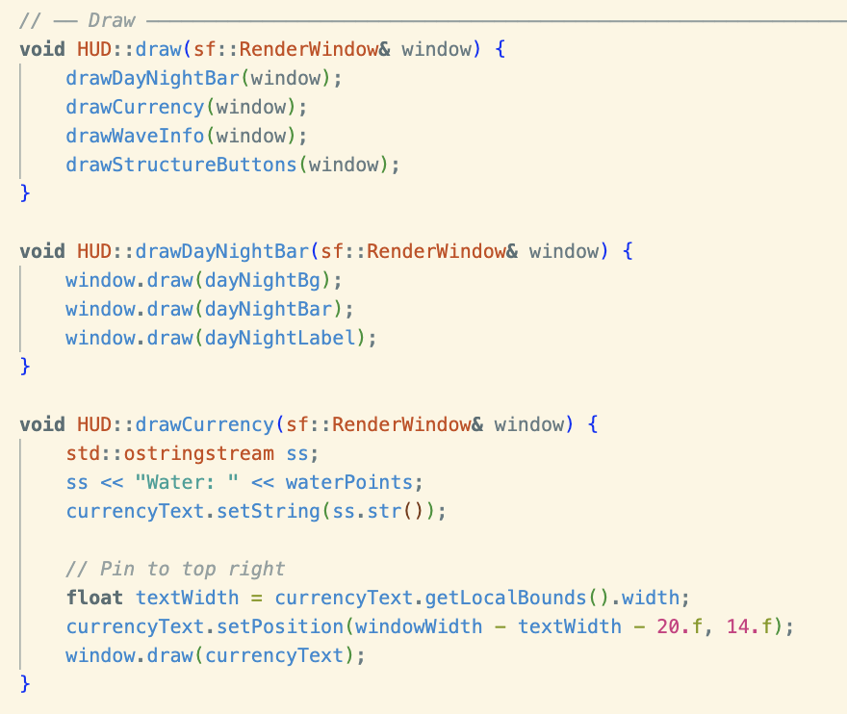
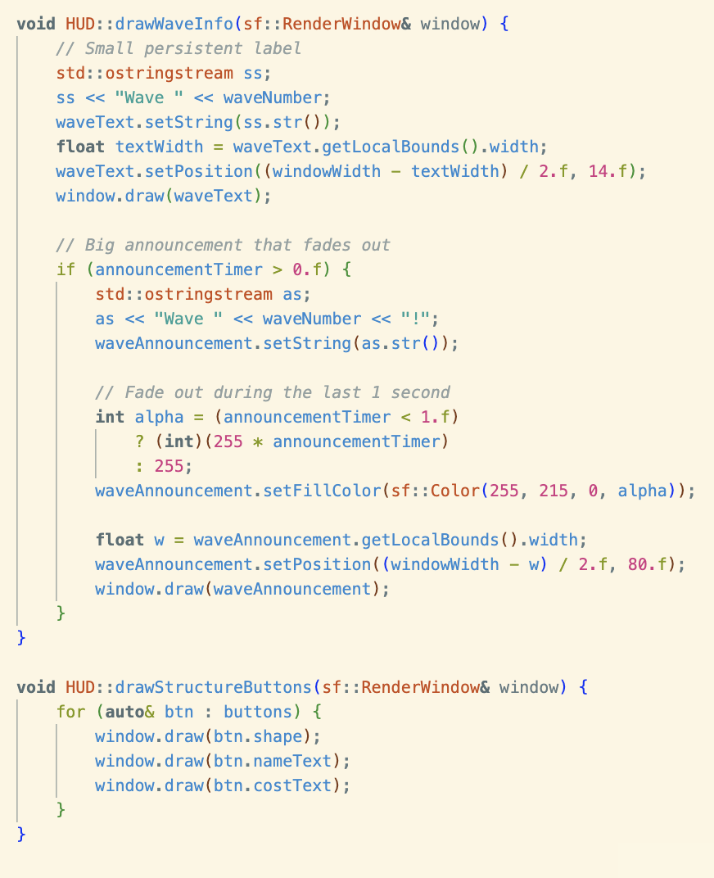
- These are the functions.

- It doesn’t really need much explanation as they are all very similar.
- Everything is drawn using one function: hud.draw().

- NOW TO intmain()
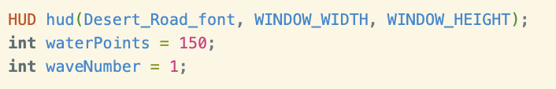
- Before the game loop, we initialize values for the waves and the currency.
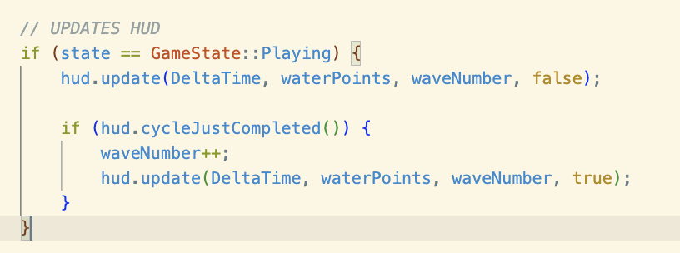

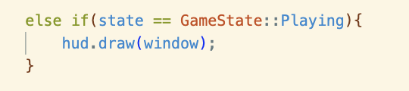
- Remember that when the player clicks “Enter” in the menu screen, the GameState changes to Playing. So these hud elements appear and are updated once the player “enters” the game.

- Because we did all the functions and stuff in a different file, all we have to do now is call a single function in main to draw all of our hud. WOW COOL 😮

- Okay, THAT’S IT FOR TODAY GRAAAAAAAAAAAAA!!!!
- FINAL OUTPUT:
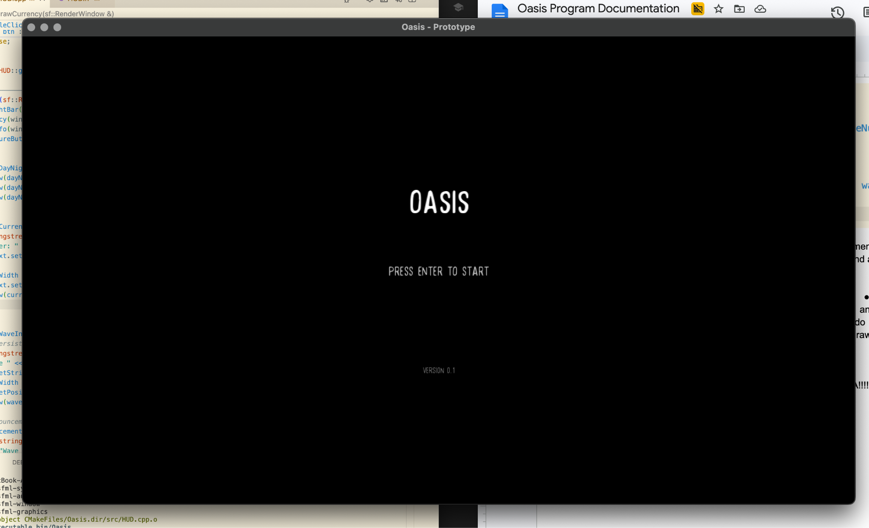
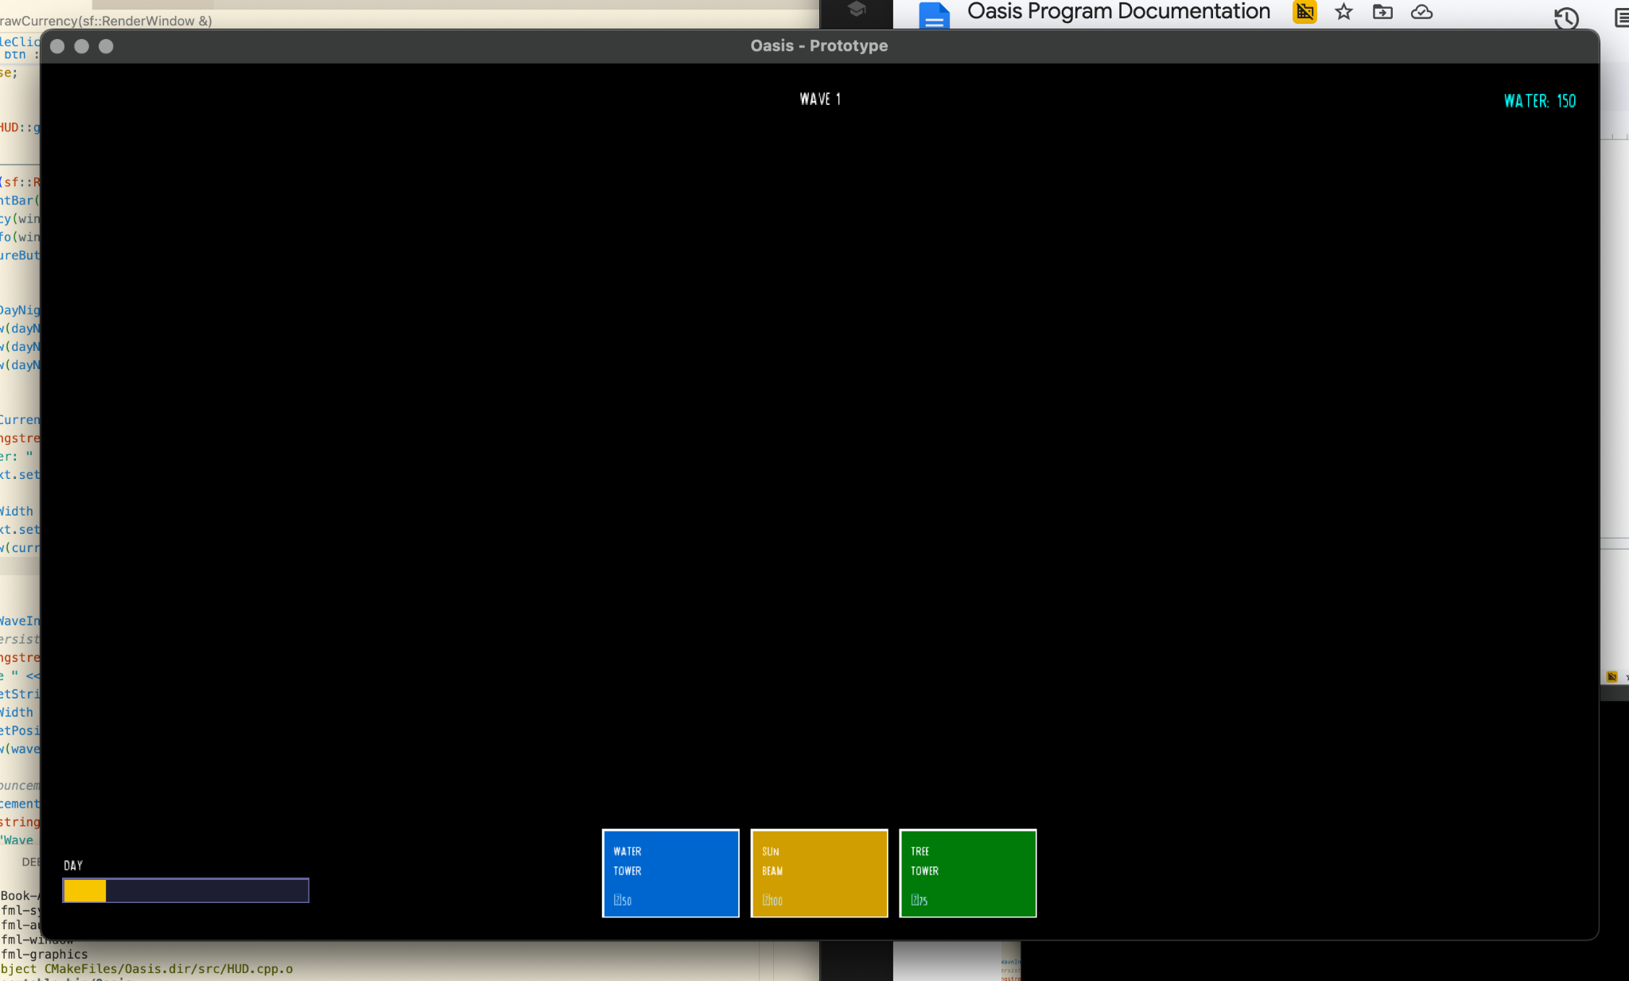

THINGS TO IMPROVE

- I have to separate the tickDayNight function as other elements of the program will use it and it being stuck inside HUD.cpp will hinder us.
  - It’s also unorganized.

- The “Wave” text appears even during the day, which is not accurate as the wave does not start until after the night comes.

May 6: MAP, PLACING TOWERS, ENEMIES
- The next step is to build the grid map and do the logic for placing down towers.

CREATING THE GRID MAP

- Let’s start with the header file: Map.h
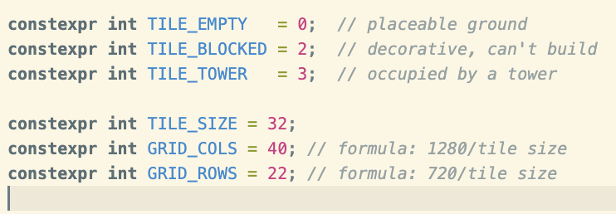
- These variables are here to adjust the characteristics of the tiles.
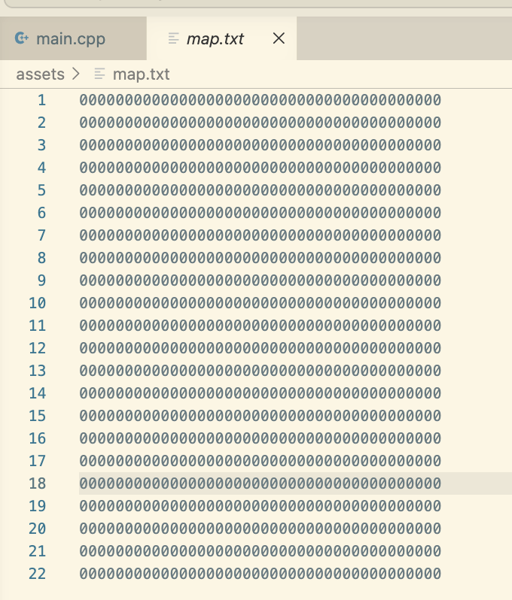
- TILE_EMPTY, TILE_BLOCKED, and TILE_TOWER are variables that will determine if the tile is available or not. This is linked to the map.txt asset.
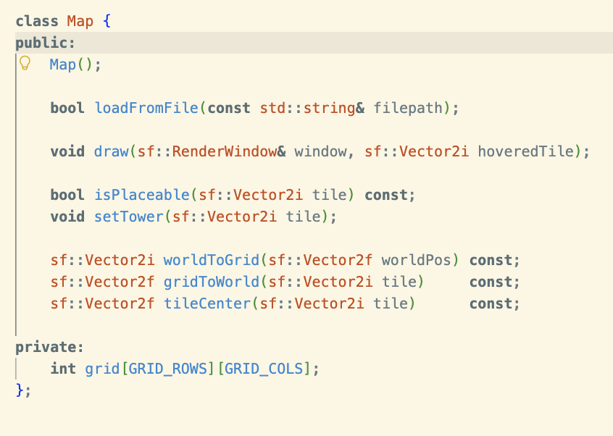
- In the class we see the functions in map.cpp and the array we use for the grid.

- Next, Map.cpp
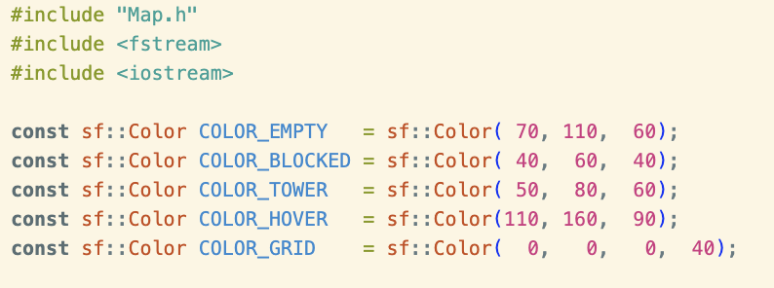
- This block of the code determines the color of the tile depending on its characteristic.

- Map() function
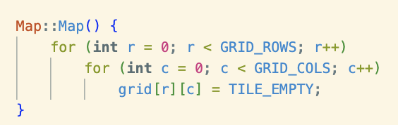

- This function initializes the grid using a nested for loop. Similar to our lessons.

- loadFromFile()
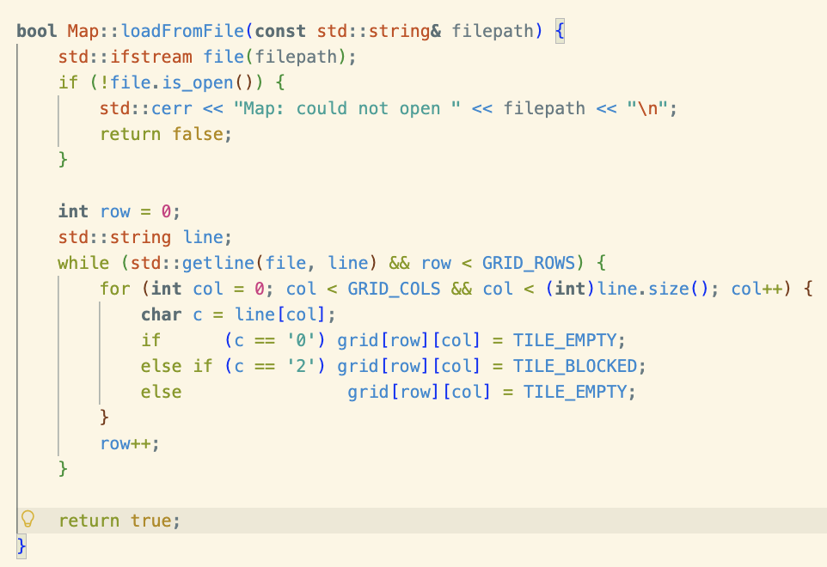

- The function takes in a file path and does two things: (1) check if it exists and (2) takes the map.txt file and places its value into the array. For example, the values in this map.txt file is put into the array called ‘grid’.

- draw()
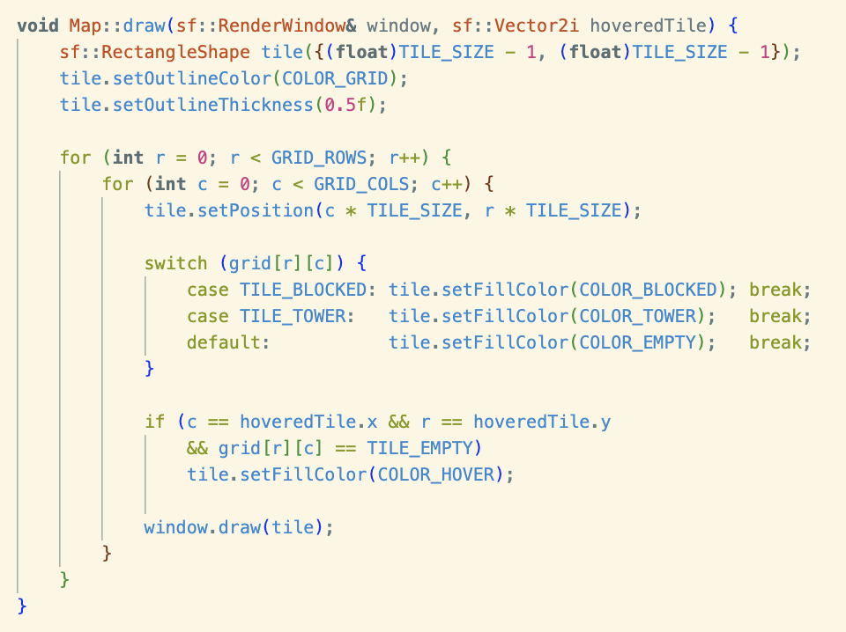
- This function helps render the actual grid.
- It first creates one “rectangle” that will be used as the base for every tile. The “-1” on the tile_size adds the illusion of black “outlines”.
- Then the nested for loop draws the “rectangle base” into every tile in the grid array.

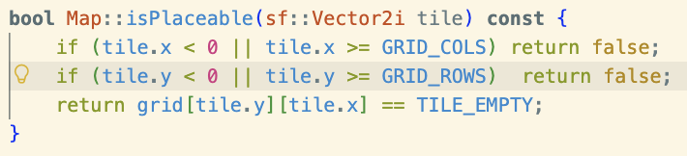
- isPlaceable()

- This checks if the tile is available for placing.
- Later used in main.cpp as a checker to put towers in the tile as an input.
- setTower()
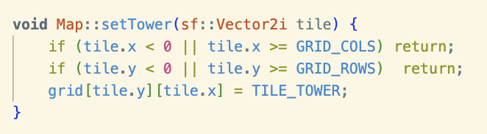
- This function is called if you want to transform a tile into a Tile_Tower.
- Is used in main.cpp once the player clicks on a grid with a selected tower.

- worldToGrid(), gridToWorld(), and tileCenter
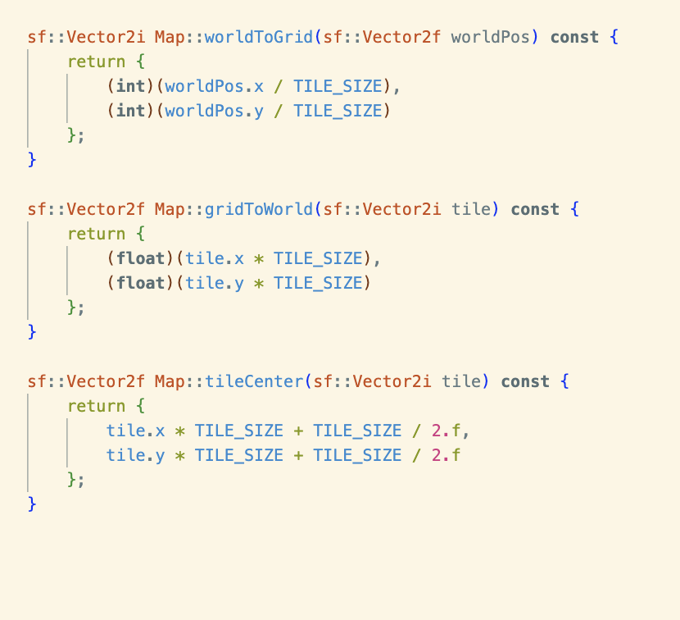

- worldToGrid(), converts the pixel coordinates of the 1280 x 720 resolution into the grid coordinates which are dependent on the TILE_SIZE.
- gridToWorld() does the opposite.
- tileCenter() is used to give an anchor point to each tile, that being the middle instead of the top left corner.
  - This is important as it saves us the hassle, especially when we start adding structures into these tiles.

So CURRENT OUTPUT LOOKS LIKE THIS:

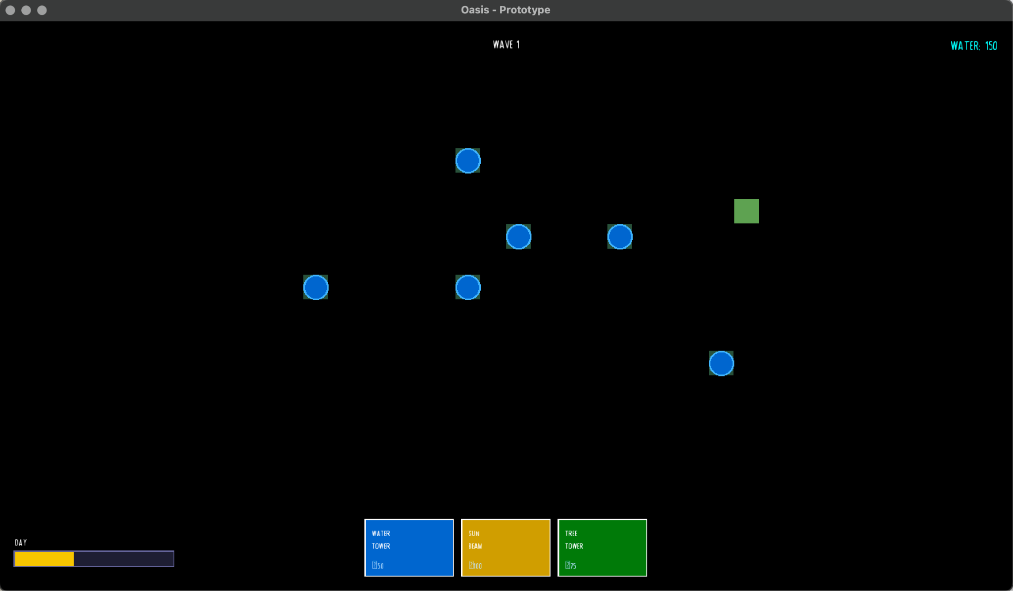
- The blue circles are “towers” that you can place ^_^ WOWOWOOWOWOWOW.

Current Problems (i can think of):
- The grid size is still up for debate as we try to finalize the map size.
- Right now, there is only one tower.

May 6 UHM AROUND 6PM

MAKING ENEMIES

- I’ve made 3 enemies.
- These enemies just go to the center. That’s all. JAKSHDGLJKASHLDKGJHA
- They also don’t follow the wave cycle just yet 🙂.

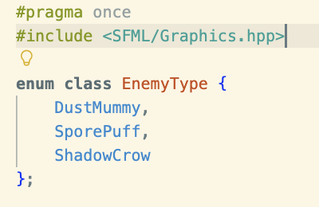
HEADER FILE: Enemy.h

- These are where the data for each enemy type are stored.

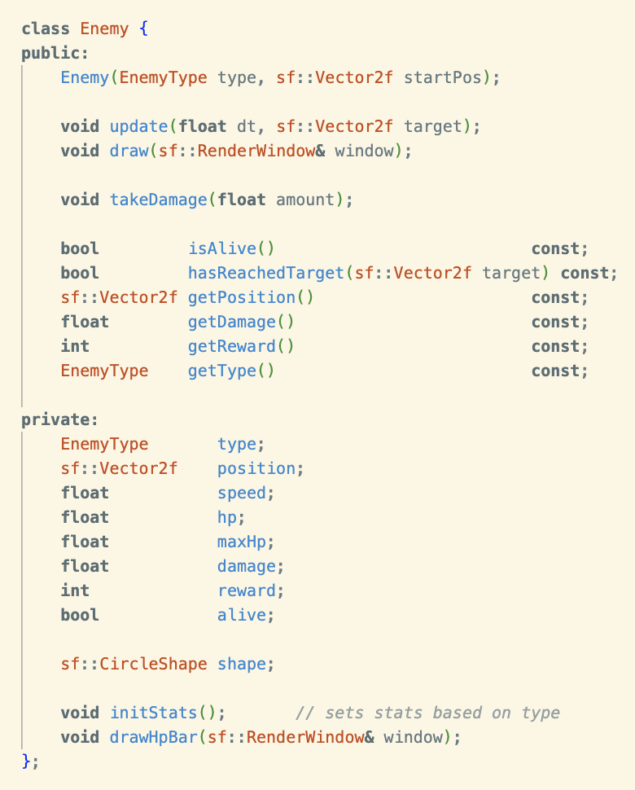

- Where the prototypes and variables for each enemy are stored.

ENEMY.CPP FILE

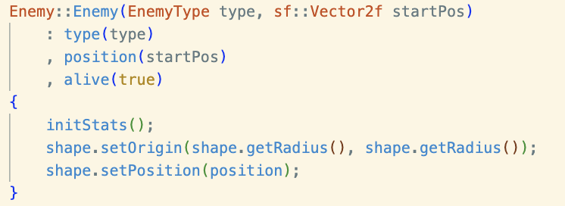
Enemy::Enemy()

- This uses the other functions in this file to construct the enemy.

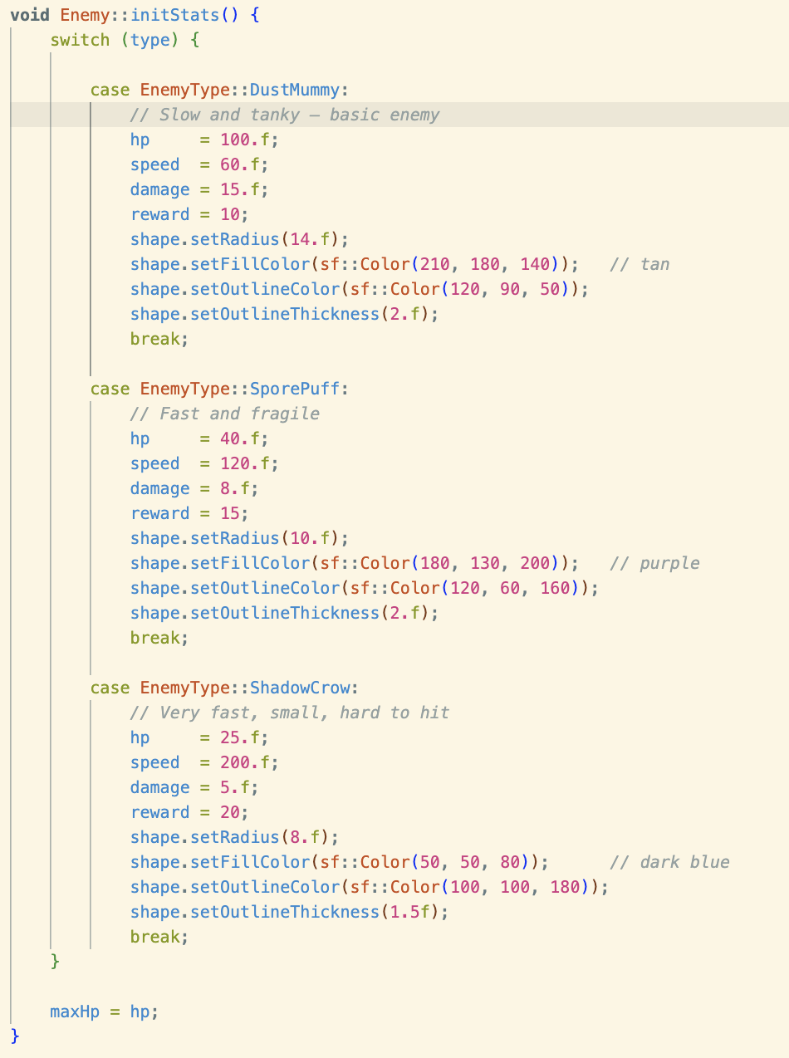
Enemy::initStats()

- This initializes the stats per enemy.
- Switch function is used to change through the different enemy types.
- This is where we edit the enemies stats.

Enemy::update()
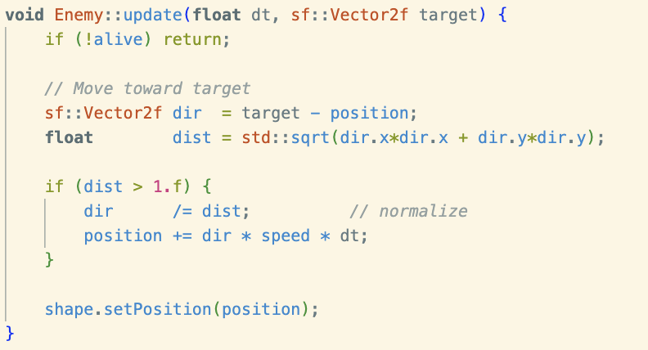
- This updates the position of the enemy
- dir gives the direction in which the enemy should “update” to. While position is the distance in which the enemy will be for the next frame.
- setPosition is a function in SFML that overrides the previous position. In this program, it uses the position variable as the argument which tells the setPosition() function to erase the previous instance of the shape and create a new one in the value that is in position.

- Oh also, there’s an if statement that immediately returns the function if the enemy is dead.

Enemy::draw()
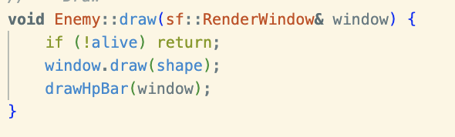
- This one just draws the enemy like previous draw functions.

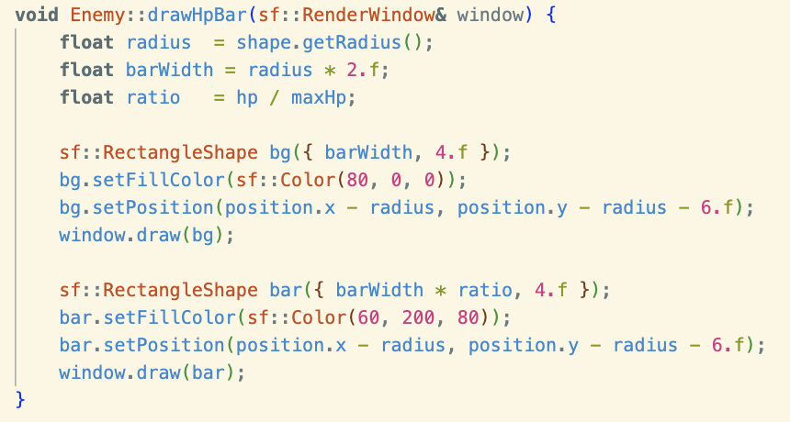
Enemy::drawHpBar()

- This one also just draws a small rectangle under the enemy.
- 2 rectangles are made: one for the max hp and then the one overlaid on top representing the hp that the enemy currently has.

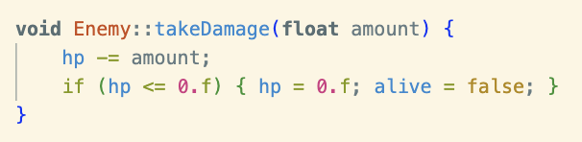
Enemy::takeDamage()
- This one is used as a way to subtract a certain amount of damage to whichever the enemy the function is used on.
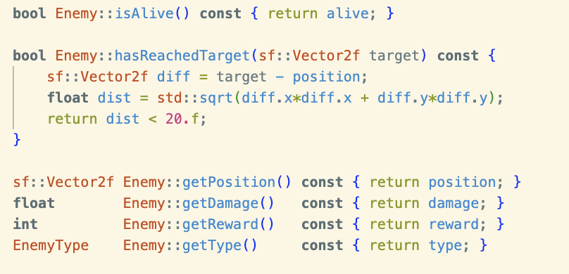
Functions acting as “CHECKS”
- isAlive() checks if it is alive
  - Remember, this is used
- hasReachedTarget() is a way to check if the enemy is close enough to its target. This will be used to check if it can damage whatever its targeting.

- The other functions are pretty straightforward. It returns whatever the name of the function is HAHSHSHHS. This is used by other functions to make it easier.

EnemySpawner.cpp
EnemySpawner::EnemySpawner()
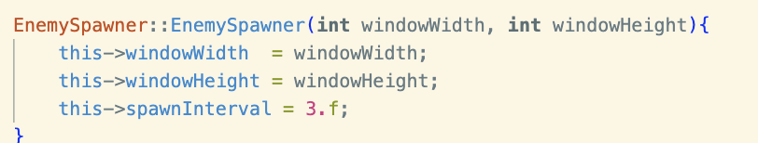
- This just combines the other functions.

EnemySpawner::update()
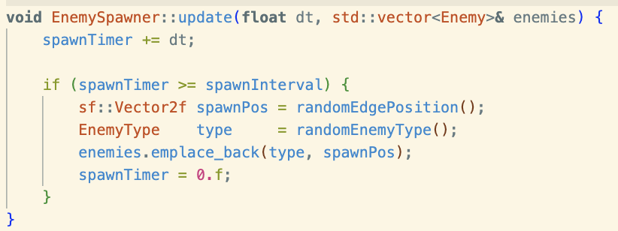
- This just updates the spawn timer. It does this by getting the DeltaTime from main.cpp and adding it to the spawnTimer.

- This timer increases until it reaches the spawnInterval. So, when that happens an enemy spawns in a random position. This is done by using the next few function (to be discussed) like randomEdgePosition(), randomEnemyType(),

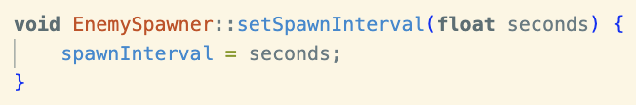
EnemySpawner::setSpawnInterval()

- This is just a way to initialize a value for the spawn intervals.
- The function itself is used as a helper for other functions like in Update().

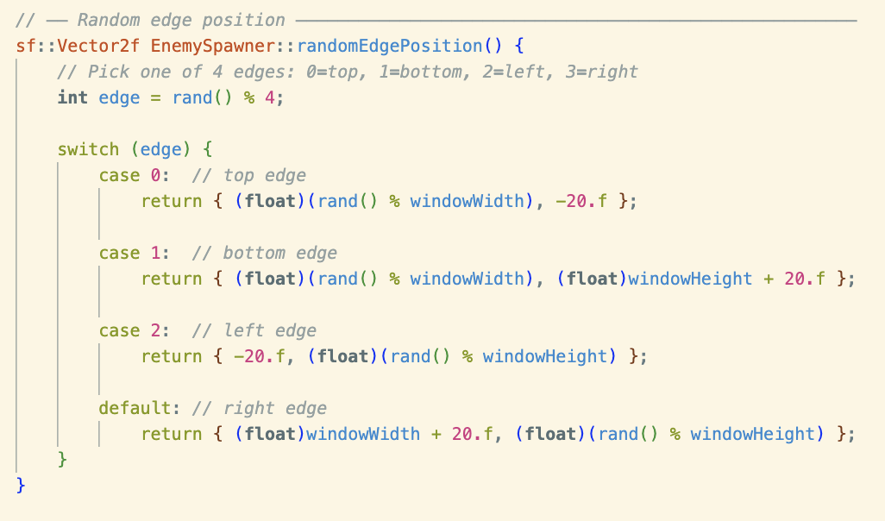
- This is a function that randomizes one out of 4 edges.

- It uses the rand() from the “cstdlib”.

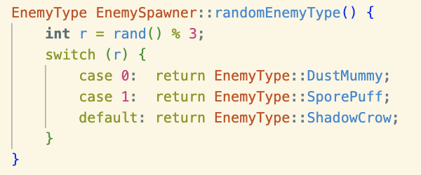
randomEnemyType()

- This function randomizes the enemy that is spawned in the update() function.

WINDOWS IMPLEMENTATION
- We tried to make the program work on chenille’s and cj’s windows laptops and failed.
- I originally used the fetch function from cmake which allows the program to fetch the sfm library directly from the github repo in the official sfml website. This works on my end but it fails on their systems due to some privacy/access errors. We’ll try again in the following days.
- A possible fix would be to download sfml 2.6.1 for each system but the reason why I used the fetch function is to avoid that. Since it’s a hassle to match the versions of Visual Studio Code, Mingw64 and the other compilers. Anyways, if we can’t find a way to make the fetch function work then we’ll do that.

May 7: CORNUCOPIAAA
- Because of the ASEAN event, the team won’t be able to meet face to face. So instead of working on SFML compatibility, we’re going to work on the “Cornucopia” structures.

- I’ve also realized that I've been a bit lazy on some of my explanations when it comes to the functions so I’ll try to be more descriptive moving forward.

MAKING THE CORNUCOPIA STRUCTURE

Just like before, let’s start with the header: Cornucopia.h
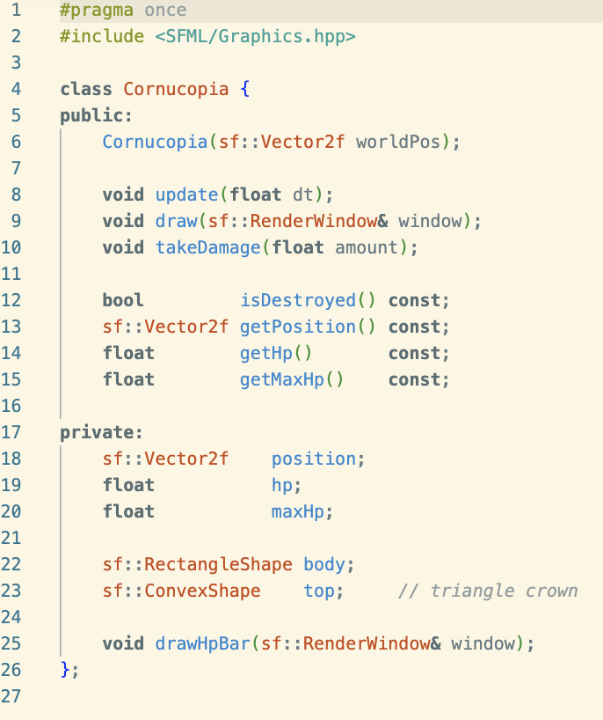
- I never really explained what “#pragma once” is, it is a preprocessor directive that just makes sure that the header file won’t be “included” multiple times. This is important as to avoid compiling errors.

- So now we have the class Cornucopia. Within this class are some helpful functions (to be discussed later) and the variables for its properties.

Cornucopia.cpp
- Cornucopia::Cornucopia(sf::Vector2f worldPos)
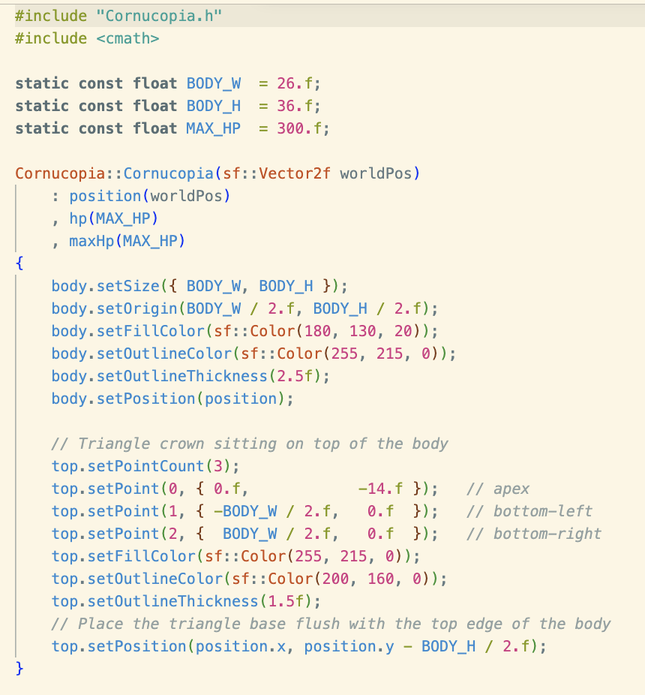
- First, we have the constructor function.
- Before the function body, we initialize the variables: position, hp, maxHp using the const variables on top and the argument to be passed through.

- Now we add a visual for the Cornucopia. This is just a draft and will be replaced by a proper sprite later on. The upper block of code sets a yellow rectangle while the lower block sets a yellow triangle on top of the rectangle.

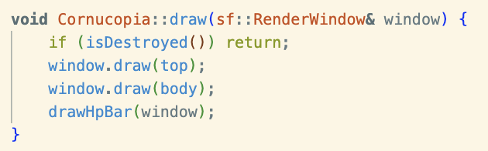
- void Cornucopia::draw(sf::RenderWindow& window)

- This function outputs the structure into the window.

- An if statement is used as a checker so that it will stop drawing if the cornucopia is destroyed.

- I want to explain sf::RenderWindow& window. As you’ve noticed we’ve used this parameter many times for other functions. This just means that the function takes the SFML window as a reference, hence “&”. This means that the function is directly accessing the window (like our lesson on pointers) instead of a “copy” of it.

- window.draw(top) and window.draw(top) just uses the built in SFML functions to “draw” the variables we made in the constructor function, Cornucopia::Cornucopia(sf::Vector2f worldPos), onto the window.

- The function also calls drawHpBar(window) which is the next function that we will discuss.

- void Cornucopia::drawHpBar(sf::RenderWindow& window)
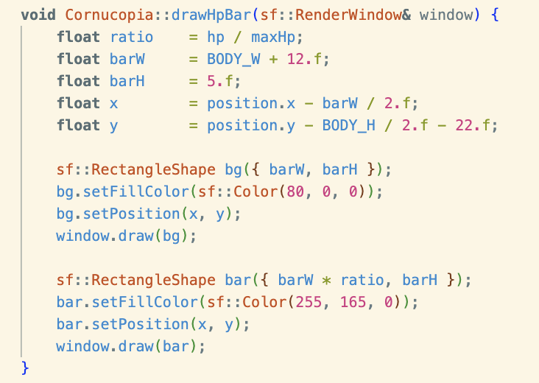
- For the hp bar, we have to create another function as this one needs to update. The current version does not though so we’ll have to work that out in the future.

- So first, we initialize the variables:
  - ratio: this is used to scale the bar
  - barW, barH, x, and y: is just used to position the health bar

- And then we draw the actual hp bar: (a) its background and (b) the overlay that represents the current amount of hp.

- Background Shape
  - So, as we know from previous examples, sf::RectangleShape is a class from SFML used to create rectangles. bg is the variable name and then we construct/initialize it by using “()”.
  - bg = “{barW, barH}”, the “{}” signifies that it is of data type Vector2f (an SFML class that gets the coordinates of a certain thing)
  - We then set characteristics to “bg” by using native SFML functions like setFillColor and setPosition.
  - Lastly, we draw bg onto the window.

- Overlay Shape
  - The flow is just the same as creating the background shape.
  - The main difference now is that we multiply barW and ratio so that it shrinks based on the tower's hp.

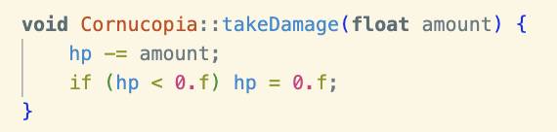
- void Cornucopia::takeDamage(float amount)

- This function is used by the enemies to actually damage the structure.
- It’s pretty straightforward, it just subtracts the amount of damage taken to its hp.

- An if statement is used as a bound to avoid getting negative values.

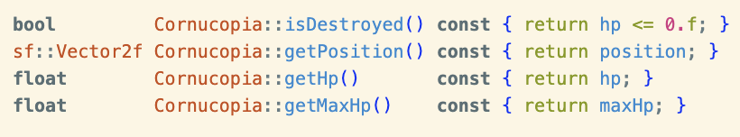
- Accessor Functions

- These functions are used as a way to access private variables from the header file. The const makes sure that they are not modified and that when the function is called the only thing it’s doing is “reading” the variable and returning it.

EDITS TO PREVIOUS FILES
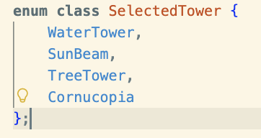
- HUD CHANGES
- Added Cornucopia in the towers to be selected.
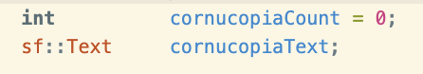
- Also added these variables (will be used later):

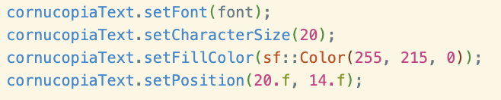
- Hud.cpp changes
- First, we added a cornucopia count on the top left corner. This will signify how many Cornucopias the player has placed. This is important because placing 5 is the win condition.
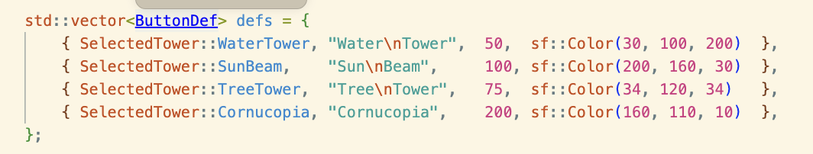
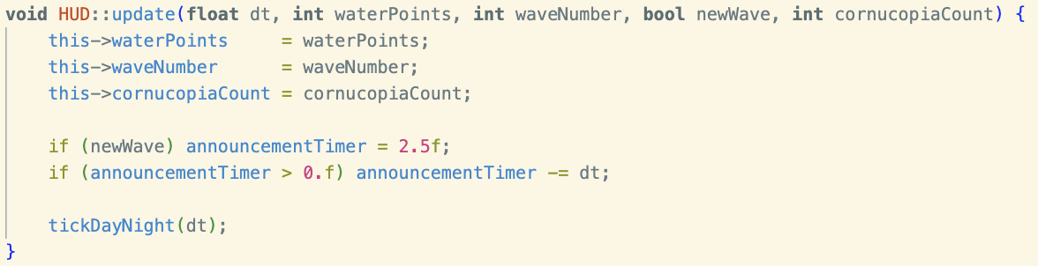
- Next, we added cornucopia into the ButtonDef vector. Added cornucopiaCount in the update function. Added drawCornucopiaCount in the draw function
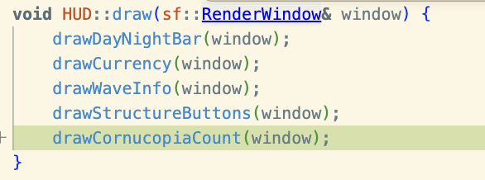

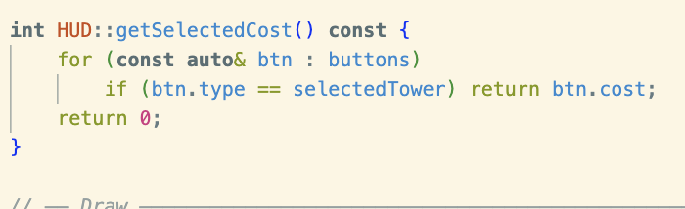
- I also added a function that returns the cost of the structure. This will be used as a way to keep track of the amount of currency the player has

- I didn’t explain this in previous uses so I’ll explain the syntax for const auto& here. This is what we call a “range-based for loop”. This type of for loop iterates over a vector. The syntax of const auto& <name of current iteration> : <name of vector> is as follows:
  - const - read only
  - auto - within the vector, the compiler will automatically figure out the data type of each element.
  - & - references each element in the vector, which avoids copying.
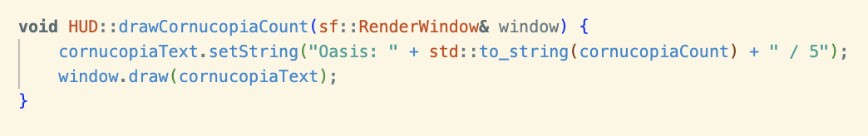
- Lastly, we added a draw function for the cornucopia text that we initialized a while ago.

CHANGES IN MAIN.CPP
- I overhauled main.cpp quite a bit so I’ll create a completely separate section for it.
- First, we added the cmath, limits, and algorithm libraries as we will be using some functions from them. We also obviously added the header for cornucopia, Cornucopia.h

- Next, added const to the resolution variables since we won’t be changing it.
- Next, added vector for cornucopias
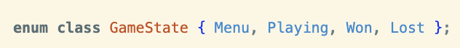
- Since the cornucopias are the core when it comes to winning and losing, we can now add a “win” and “lose” game state.

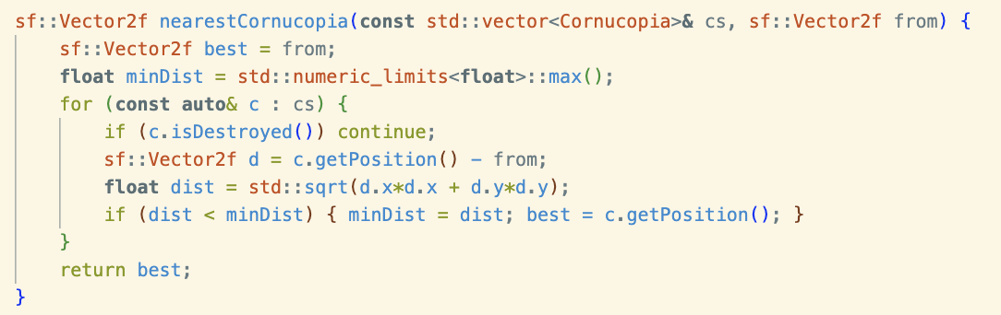
- sf::Vector2f nearestCornucopia(const std::vector<Cornucopia>& cs, sf::Vector2f from)

- Added a function that will help enemies move towards the nearest Cornucopia.
- So, as seen in the picture, the function returns a Vector2f data type (x,y) which is the coordinates of the nearest Cornucopia.
- In the body, we first set it up.
  - The function receives a vector2f from. This is the coordinate of the enemy's position.
  - We assign from to another vector2f named best, as this will be the basis before we run a for loop to get the actual “best”/nearest cornucopia to go to.
- After, we do a for loop that iterates over every cornucopia.
  - if(c.isDestroyed()) just skips dead cornucopias.
  - We then create a new variable d which is the distance from current cornucopia in the iteration (c.getPosition()) to the enemy (from)
  - Then we use the pythagorean theorem to get a straight line path from the enemy to the cornucopia.
  - Another if statement is used as a way to overwrite previous iterations if a closer cornucopia is found.

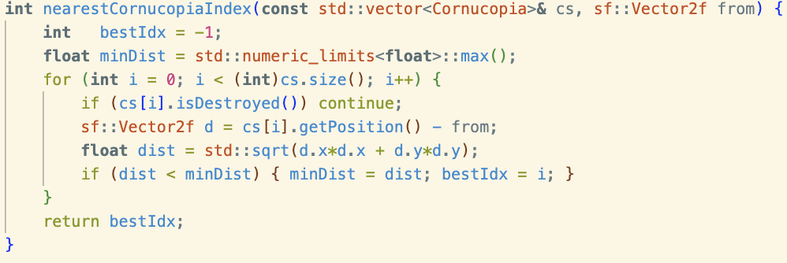
- int nearestCornucopiaIndex(const std::vector<Cornucopia>& cs, sf::Vector2f from)

- This one just returns the index of the nearest cornucopia.
- It is very similar to the previous function so I won’t delve too deep into it.
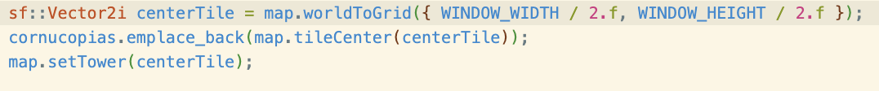

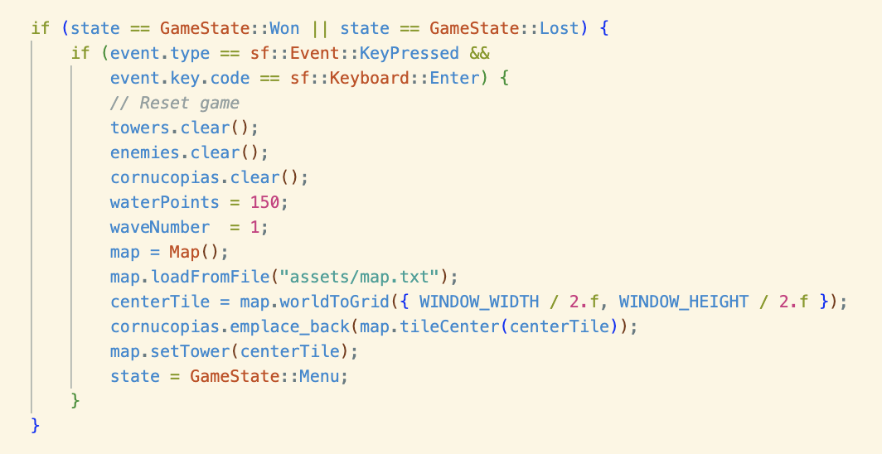
- The block above places a Cornucopia in the center of the map.

- Since we added two new game states: won and lost, we need a way to exit those screens.

- The player can do this by pressing the “Enter” key. The syntax is identical to the other game states.

- When this block of code is run, it will clear the window and go back to the menu screen.

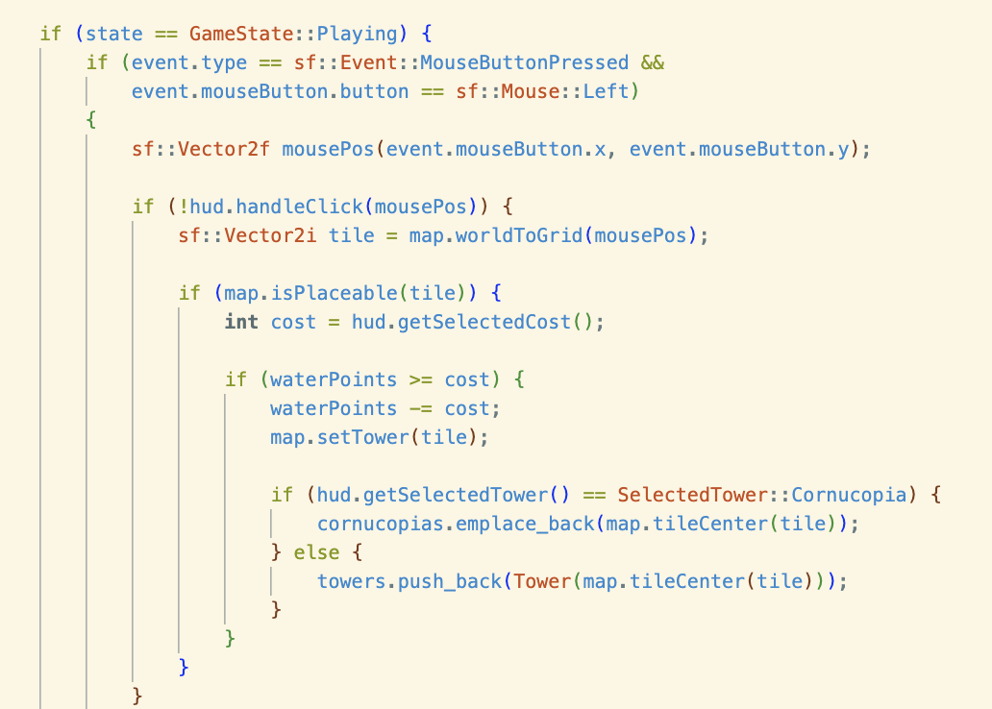
- I edited the Playing gameState. Now, the costs of the towers are reflected properly and the player will lose water points when placing these towers.

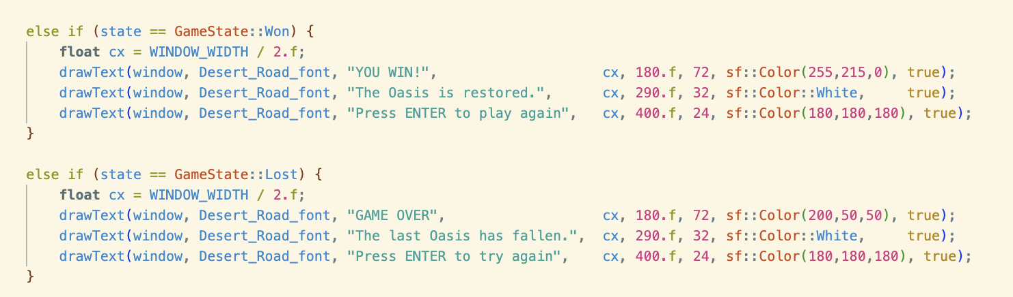
- In the rendering section, I've added elements to the win and lost screens.

CURRENT OUTPUT:

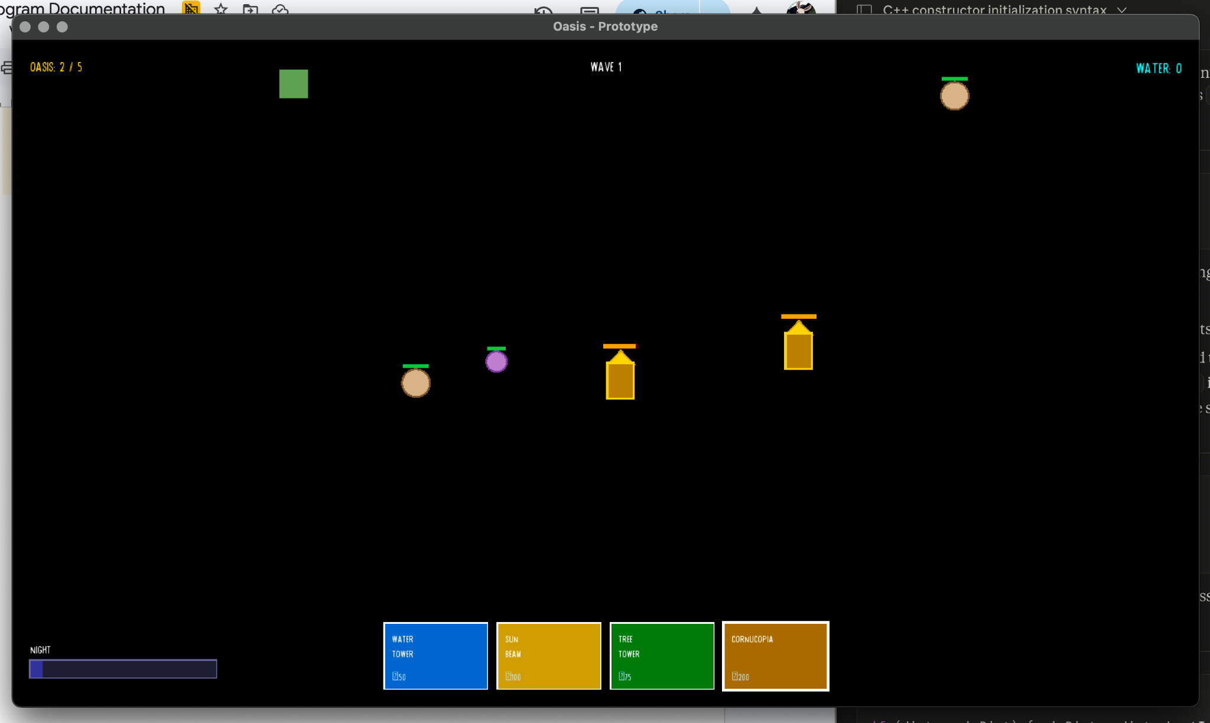
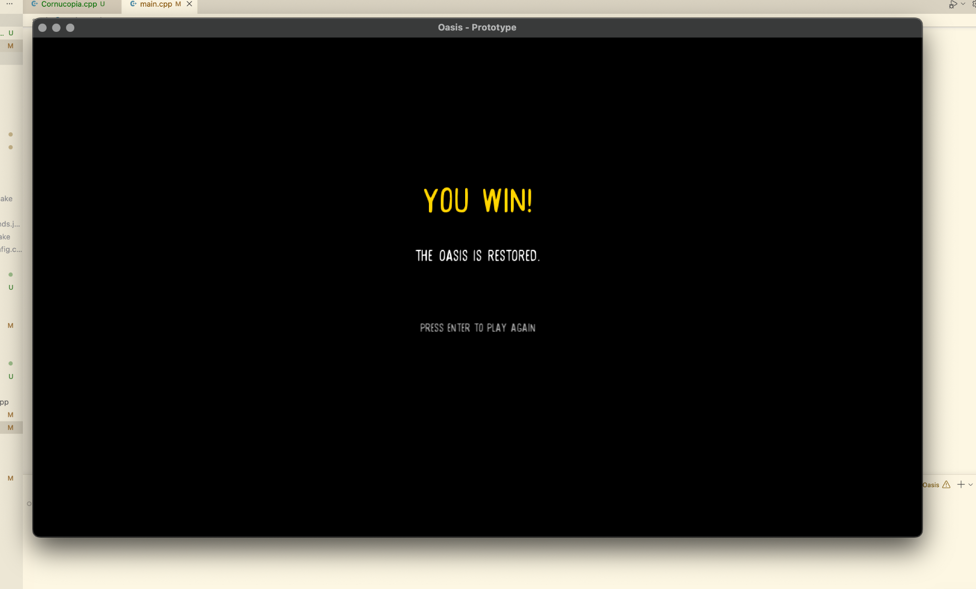

May 8: Fixing Bugs and Inconcistencies
- The goal for today isn’t really to build anything new but to adjust the elements to match the game design.

- Enemies
  - Don’t let them die after contact with Cornucopia
  - Increase the amount of enemies that spawn.
  - Give them melee combat moves.
    - Dust Mummy: medium attack speed
    - Spore Puff: medium attack speed
    - Shadow Crows: Fast attack speed

- Give other towers health bar
- Let enemies also target these towers (other towers that are not Cornucopia).

CHANGES

- In enemy.h, we added bool consumeAttack(), float values: attackSpeed and attackTimer, added bool values: attacking. Explanation for these functions and variables will be explained.

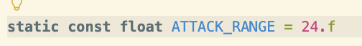
Enemy.cpp
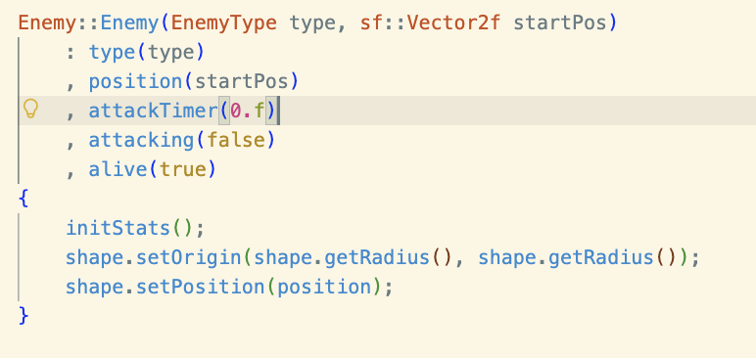
- This variable is used to determine the enemies “attack range” in which they can start “punching” their target.

- initialized attackTimer and attacking variables in the constructor function: Enemy::Enemy().

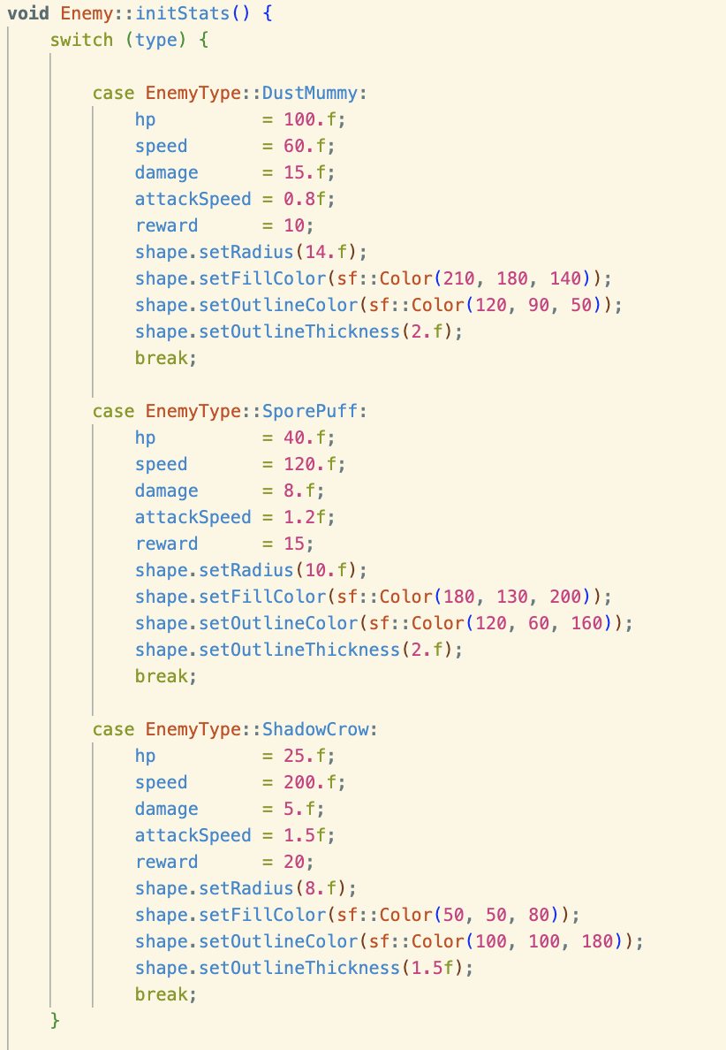

- added attackSpeed variables to the enemies.


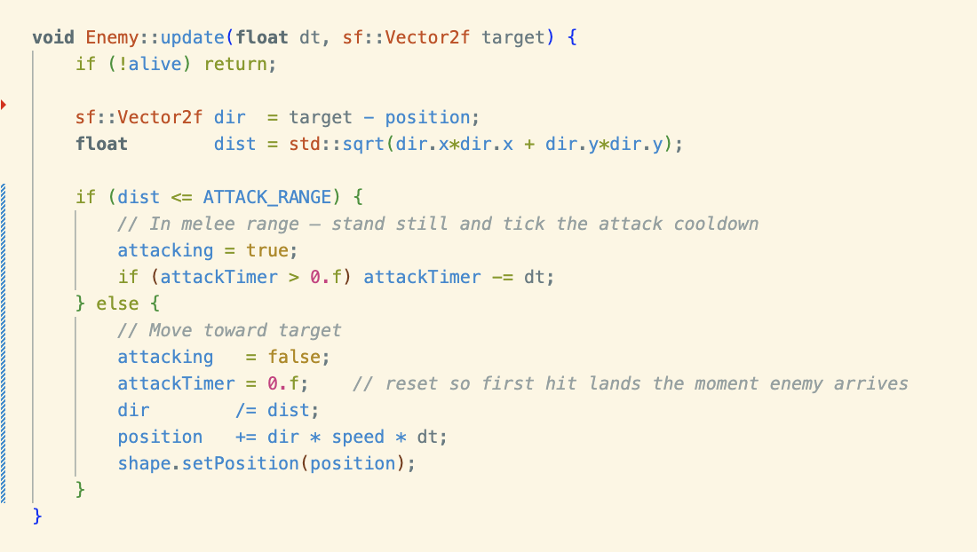
- Updated the update() function so that the enemy can reduce the target’s hp when the distance of enemy from its target is less than the ATTACK_RANGE.
  - If this is true, then the attacking is set to true which is later used by the consumeAttack() function.
  - If not, then the enemy will continue updating and moving towards the nearest cornucopia.
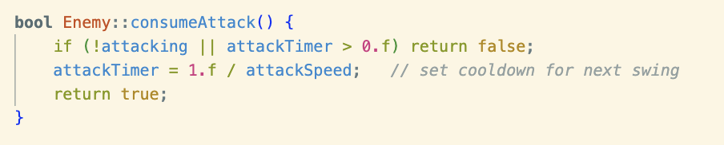

- consumeAttack() just makes it so that, after the enemy attacks a cooldown is set. It also makes it so that if the enemy is not in attacking range (attacking = false) or attack is on cooldown (attackTimer > 0.f) then the cooldown timer will not restart.
  - Another thing it does is that it checks if the enemy is within range to attack.

main.cpp
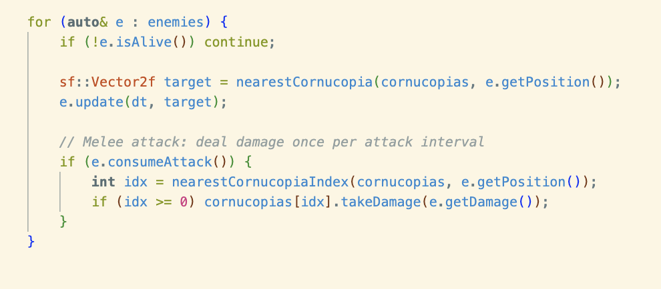

- After the enemy “updates”/walks toward the nearest Cornucopia, the enemy will attack.
- Remember in the e.consumeAttack() function, it checks if the enemy is within range so if not it will return false and the cornucopia will not take damage. If the function returns true the program will get the index of the nearest Cornucopia and run the takeDamage() function which will reduce its hp.

May 9: Enemy Adjustments + Tower Shooting
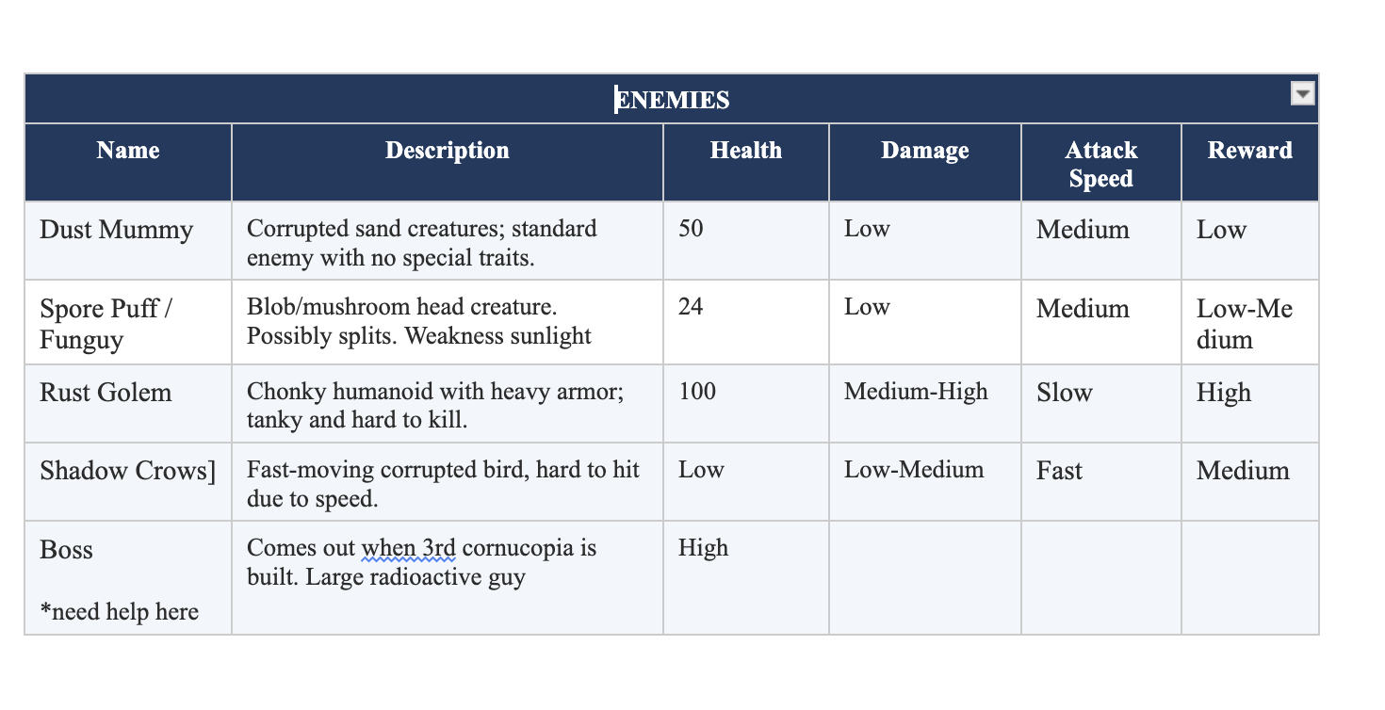
- I’m starting this at 5:44 pm.

To do list:

- Increase duration of night time
- Make enemies spawn only during the night
- Create Rust Golem
- Give enemies their unique traits >>>>>
- Make Tower shoot

INCREASING DURATION OF NIGHT TIME
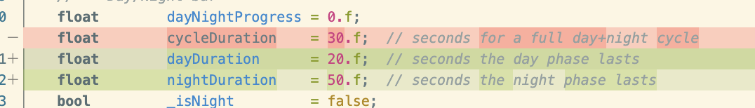
- the red and green highlight is a github feature that highlights changes from the previously committed version to the current one.

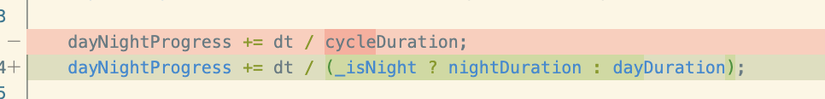
- First, I replaced cycleDuration with dayDuration and nightDuration in HUD.h. This will be used to separate the duration of day and night (and increase the night time without changing the duration of day time)

- changed dayNightProgress so that the hud element will update with respect to dayDuration during the day and nightDuration during the night.
- Syntax for (_isNight ? nightDuration : dayDuration):
  - in c++, this is just an if statement. If _isNight is true then it will return the value before the colon (:), if it is false then it will return the value after the colon.

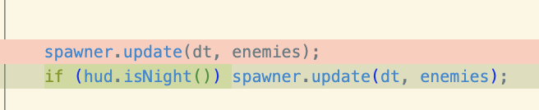

- In main.cpp, we just added an if statement so that the enemy will only spawn during the night.
- Syntax: hud.isNight() just checks if the value of isNight() in hud variable would return true or false. If it does return true, then the spawner would update which spawns enemies.
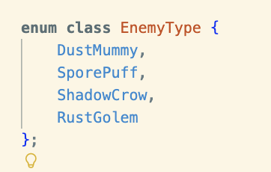
CREATING RUST GOLEM AND THE UNIQUE TRAITS OF EACH ENEMY

- first, I added Rust Golem to the enum class in Enemy.h
- I also added splitGeneration in the private section of the class.

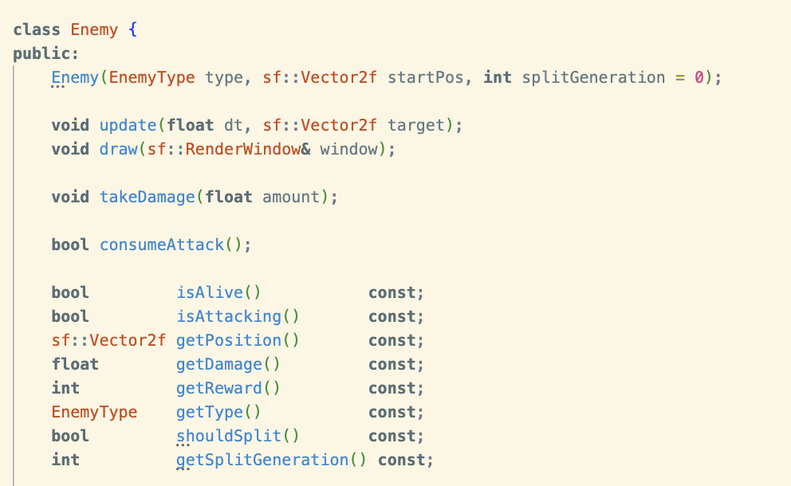

- I added splitGeneration = 0 to the parameters of Enemy. Used for the spore puffs.

- We also add the functions shouldSplit() and getSplitGeneration() into the class. Later, i’ll explain what’s happening inside those functions.

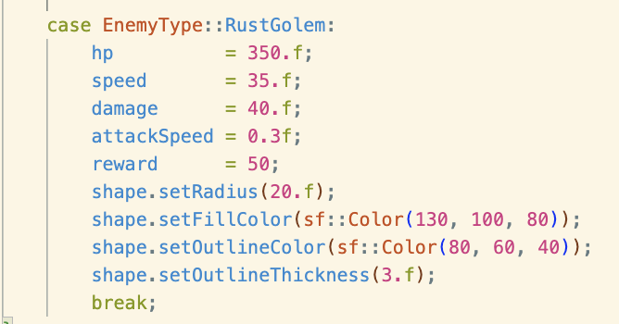
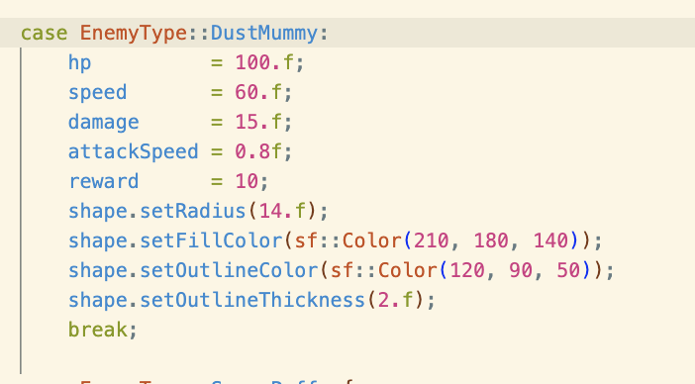
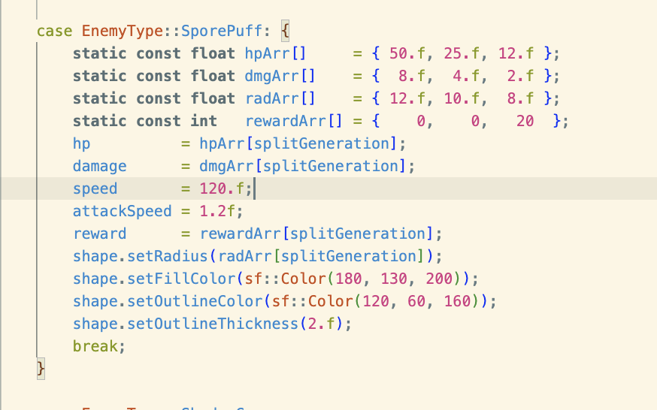
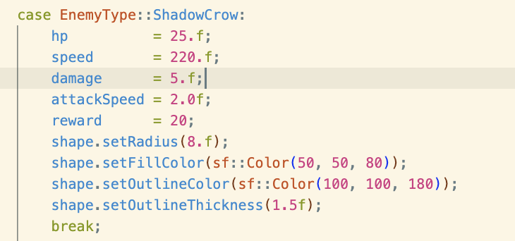

- just adjusted the stats of each enemy to match their characteristics based on the Game Design section of the Project Master Document in this section of Enemy.cpp.

- For the SporePuff, I used an array to give stats for each “generation” of slime. So for example, the hp of the 1st generation is 50.f, 2nd generation is 25.f, and 3rd generation is only 12.f. The same is done for the damage, reward, and its radius (size).

- The RustGolem is new but how we implement it is just very similar to the other enemies.
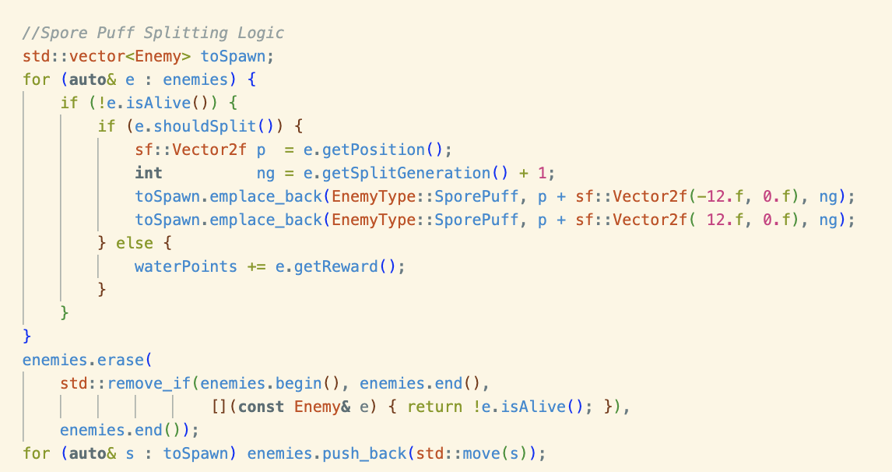

- In main.cpp, under the update section, I added the splitting logic of the Spore Puff.
- std::vector<Enemy> toSpawn;
  - Just creates a vector of type Enemy for the next generation of spore puffs to spawn.
- for (auto& e : enemies) and if(!e.isAlive())
  - Is just a for loop that cycles through every enemy and checks for those who are dead.
- if(e.shouldSplit())
  - Checks if the enemy ShouldSplit().
  - Which does two things: (1) Checks if the enemy is a SporePuff and (2) if the splitGeneration is less than 2 (if it isn’t then it means that the enemy has already split 2 times). If these checks are true that the function returns true but if not then it returns false.
  - When e.shouldSplit() is false then the player gets waterPoints.
  - When e.shouldSplit() is true then the spore puff splits into 2.
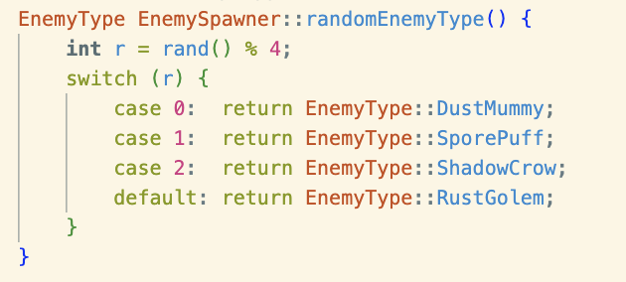
- Then after all that, we erase the dead enemies in the vector.

- Then we add the Rust Golem into the spawn pool in EnemySpawner.cpp
MAKE TOWER SHOOT
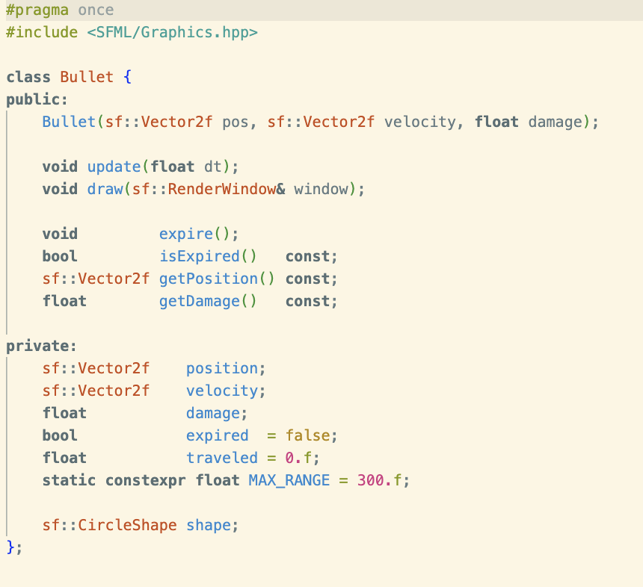

- First, i created bullet.h to store the bullet class. In this class we have the core functions: Bullet(), update(), draw(). Then the other helper functions.

- We also have variables to store the characteristics of these bullets.

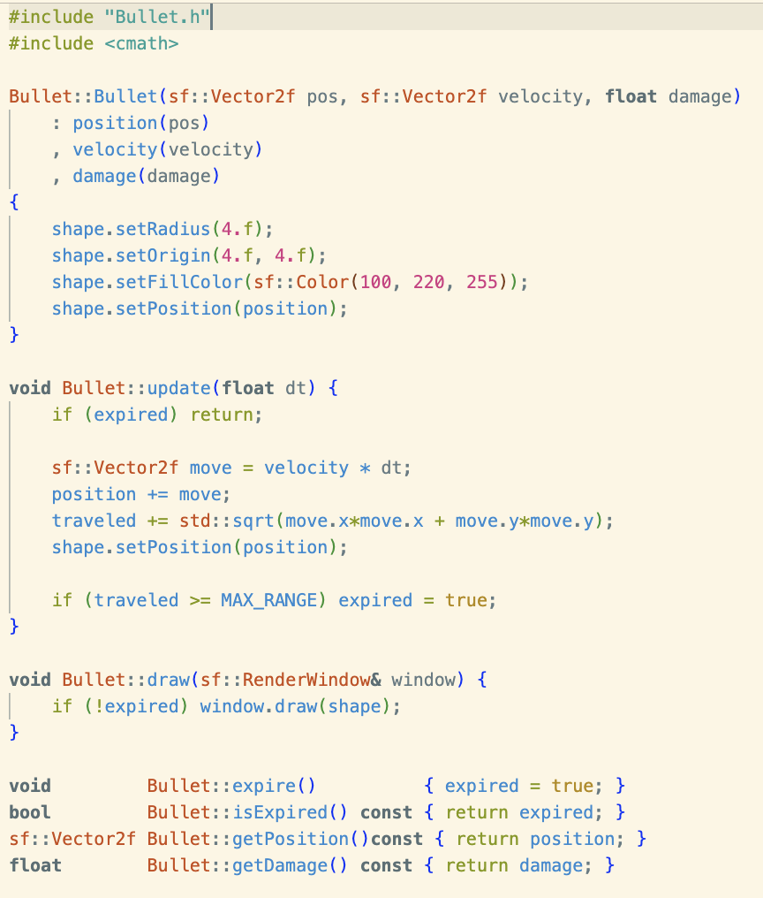

- Then bullet.cpp is where we created the function bodies.

- First is the constructor function that initializes the bullet’s position, velocity, and damage. We also construct the bullet’s visual a small blue circle.
- Then, we added the Bullet::update(), this just updates the position of the bullet. I won’t delve deeper as this is very similar to the logic of the first draft we made

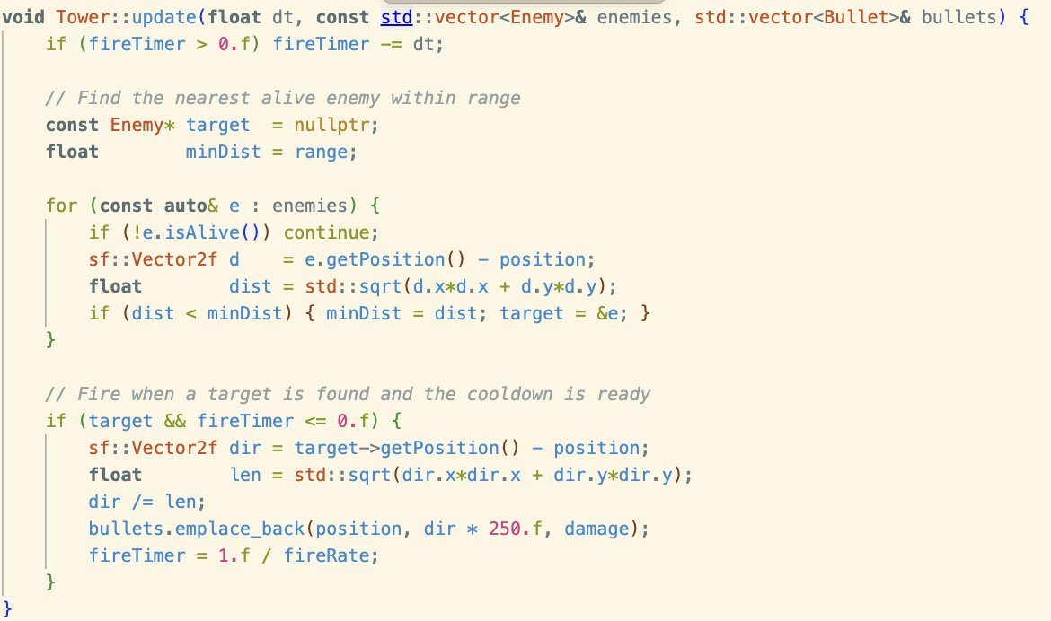

- in tower.cpp, we add functionality to the update() function. This is also just very similar to the first draft we made. I’ll briefly explain it here.

- First we find the nearest enemy within range. First we initialize a pointer to an Enemy value named target, we set its value to be a null pointer. In c++ we do that by using nullptr. Then we set the minDist to be the tower’s range.

- A for loop cycles through every enemy in the vector and if the enemy is alive we get d which is a Vector2f that gets the direction of the tower to the enemy. Now that we have the direction, we then get the distance from the tower to the enemy. We do this by using the pythagorean theorem.
- Next, an if statement is used to store the data of the enemy if its nearer than the minimum distance of the current iteration of the loop.
- Now that we have a target, we can start firing. This is done by, again, getting the direction and distance between the tower and enemy. Then bullets.emplace_back() function is called which spawns a “bullet” at the towers position going at the dir * speed of the bullet (250.f).

- Also, at the start of the function there is an if statement that acts as a cooldown for when the tower should fire again.

- in main.cpp, we initialize a vector where we can put newly created bullets. We also add the bullets.clear() in the won/lose gamestate to reset.

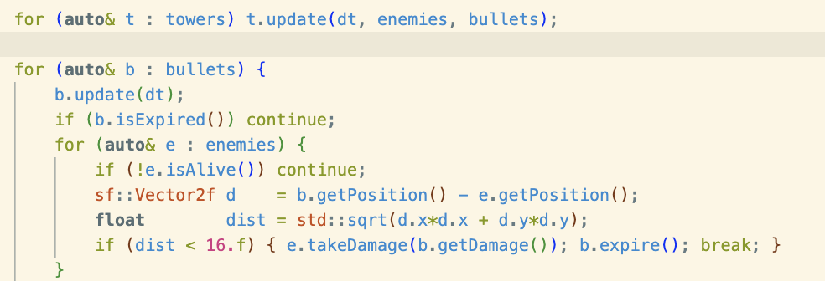
- Next in the update section of main.cpp, we add a for loop to cycle through all the towers and run the update function.
- Then we cycle through all the bullets visible in the screen and run the update function for it. If the bullet isExpired() then it means the bullet is dead and we move on to the next iteration of the loop. If isExpired() returns false then we run another for loop that cycles through every enemy on the screen. If the enemy is dead we move on to the next enemy in the iteration. If the enemey is alive, we get the direction and distance between the enemy and the bullet. If the distance between them is less than 16.f then the enemy takes damage (obviously because the “bullet” has “hit” them).

- Finally, we draw the bullet using a for loop and b.draw(window), similarly to how we render all the other elements.

- THEN, of course, we add the bullet.cpp to the executable list in the cmake text file so that the program can be compiled properly.

- ALSO, i added the range indicator like in the first draft. I just did this by adding the variable rangeCircle of type CircleShape (data type in SFML for creating circles).
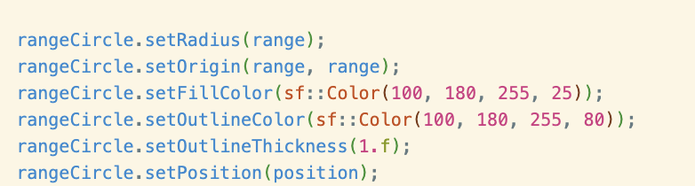

- In tower.cpp, I added these characteristics for the range indicator.

- Then added, window.draw(rangeCircle) in the Tower::draw() so that both the tower and its range is rendered onto the window when the function is called.

May 10: Tower Adjustments
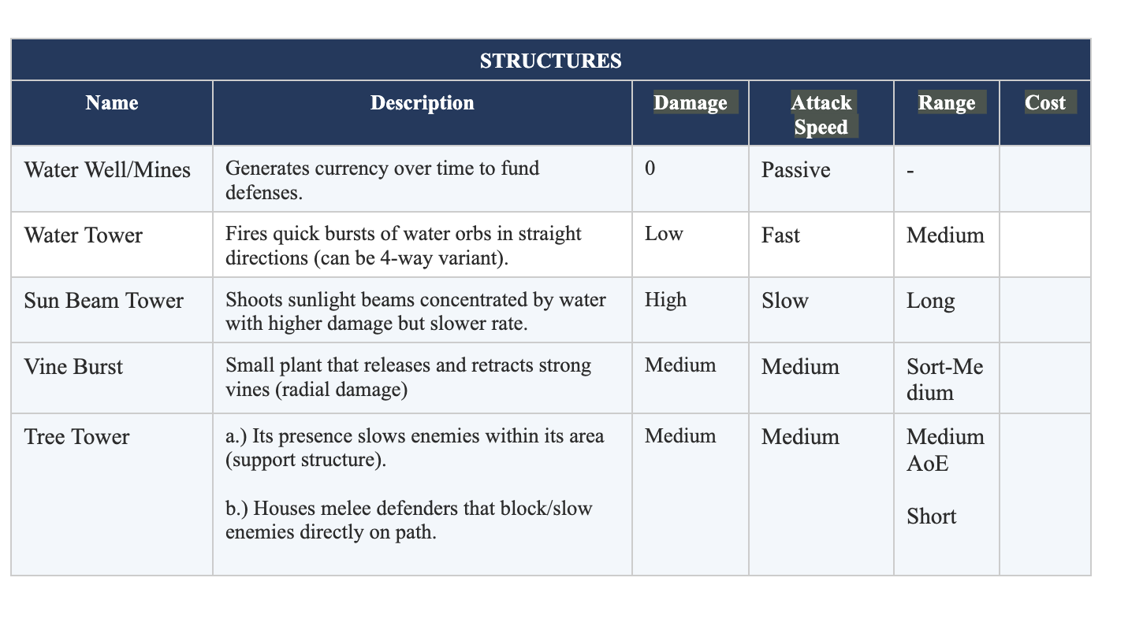
- For today, we’re going to actually implement the other structures and their unique traits.

- Make Water tower
- Make Sun Beam Tower
- Make Tree Tower
- Make Vine Burst Tower

First, let’s make the Water Tower.

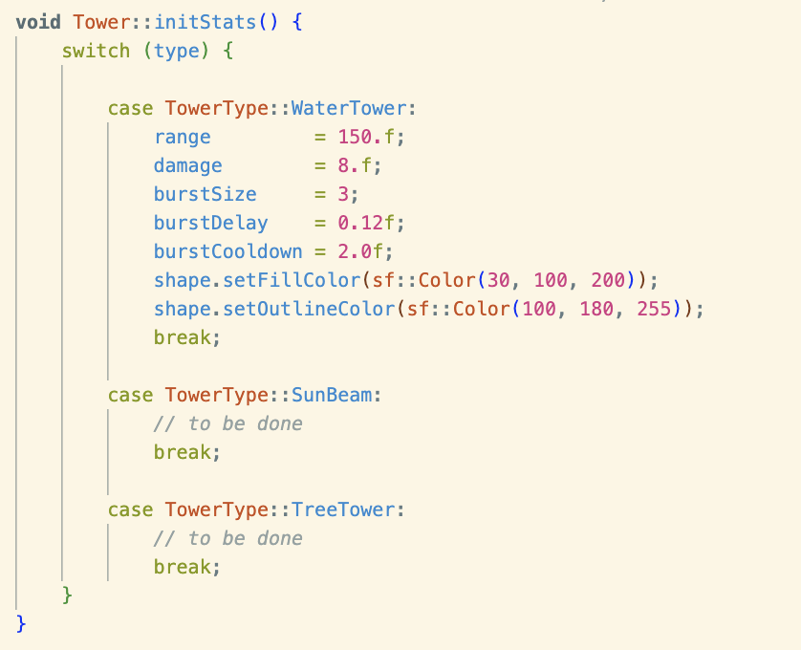
void Tower::initStats()

- I used a switch function so that we can separate each tower type and give them individual stats. Right now the hud only shows water tower, sun beam, and tree tower so I’ll just work on those for now then just add the vine burst tower later (cause feeling a bit lazy to edit the hud).

- The variables are pretty self explanatory and will be used later on to access the needed statistics. We also set the tower’s color here.

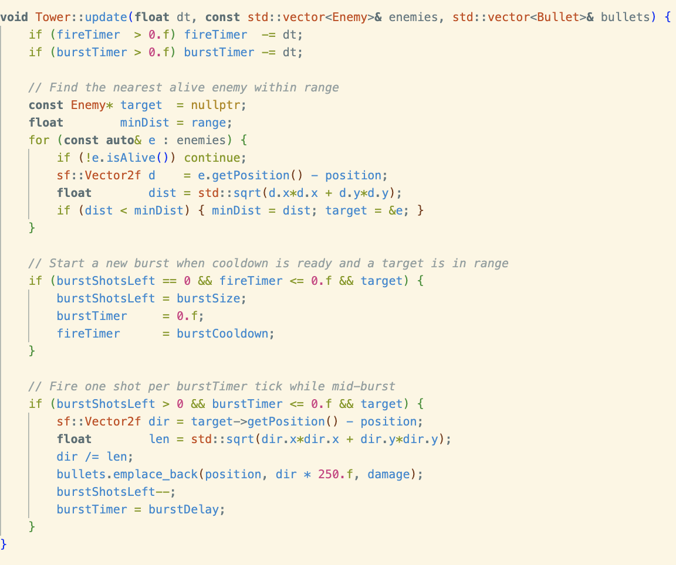
void Tower::update(float dt, const std::vector<Enemy>& enemies, std::vector<Bullet>& bullets)

- The changes done on the update function is mostly for the “burst fire” logic.

- burstTimer is used for the interval between the 3 bullets in one burst. While, recall that, fireTimer is used for the cooldown of between bursts (in the context of the water tower).

- To start a “burst” , I added an if statement that runs only if three conditions are met: bursShotsLeft is 0 (meaning that the tower is not shooting a burst in that frame), the fireTimer is less than or equal to 0 (meaning the cooldown is finished), and the pointer target actually points at an enemy and not just a nullptr (meaning there is a target within range). If all these conditions are met, then the program “loads” a burst. Meaning burstShotsLeft would get the value of burstSize (in this case it’s 3), the burstTimer becomes 0, and the fireTimer would get the value of burstCooldown (which is the key to firing three bullets quickly).

- So the previous if statement is used as a timer for when the tower will shoot its next burst. Now, another if statement is used for the actual burst. We do this by getting the direction and distance between the target and the tower. Next, we “animate” the bullets using the bullets.emplace_back() function (like how we used it before). After that we decrease burstShotsLeft by 1 and officially start the burstTimer by giving it the value of burstDelay (found in the initStats() function).

Changes in main.cpp
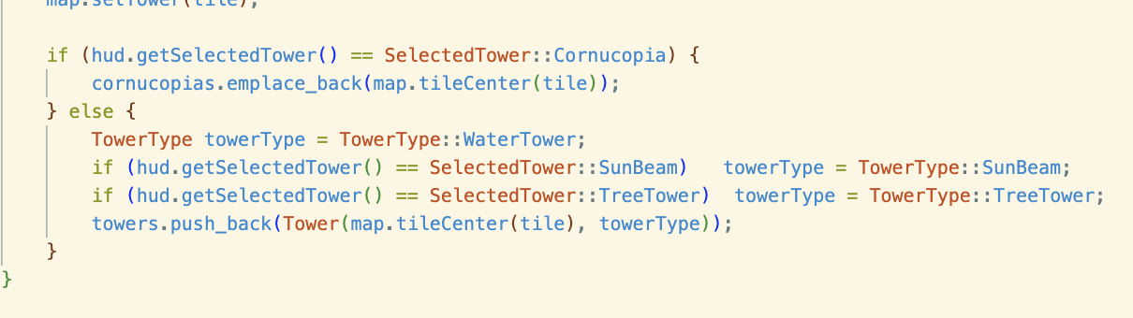

- All we did here was give the different hud buttons its own tower structure. And now, when we use push_back, we are actually referring to a specific tower type and not just one.

OUTPUT:

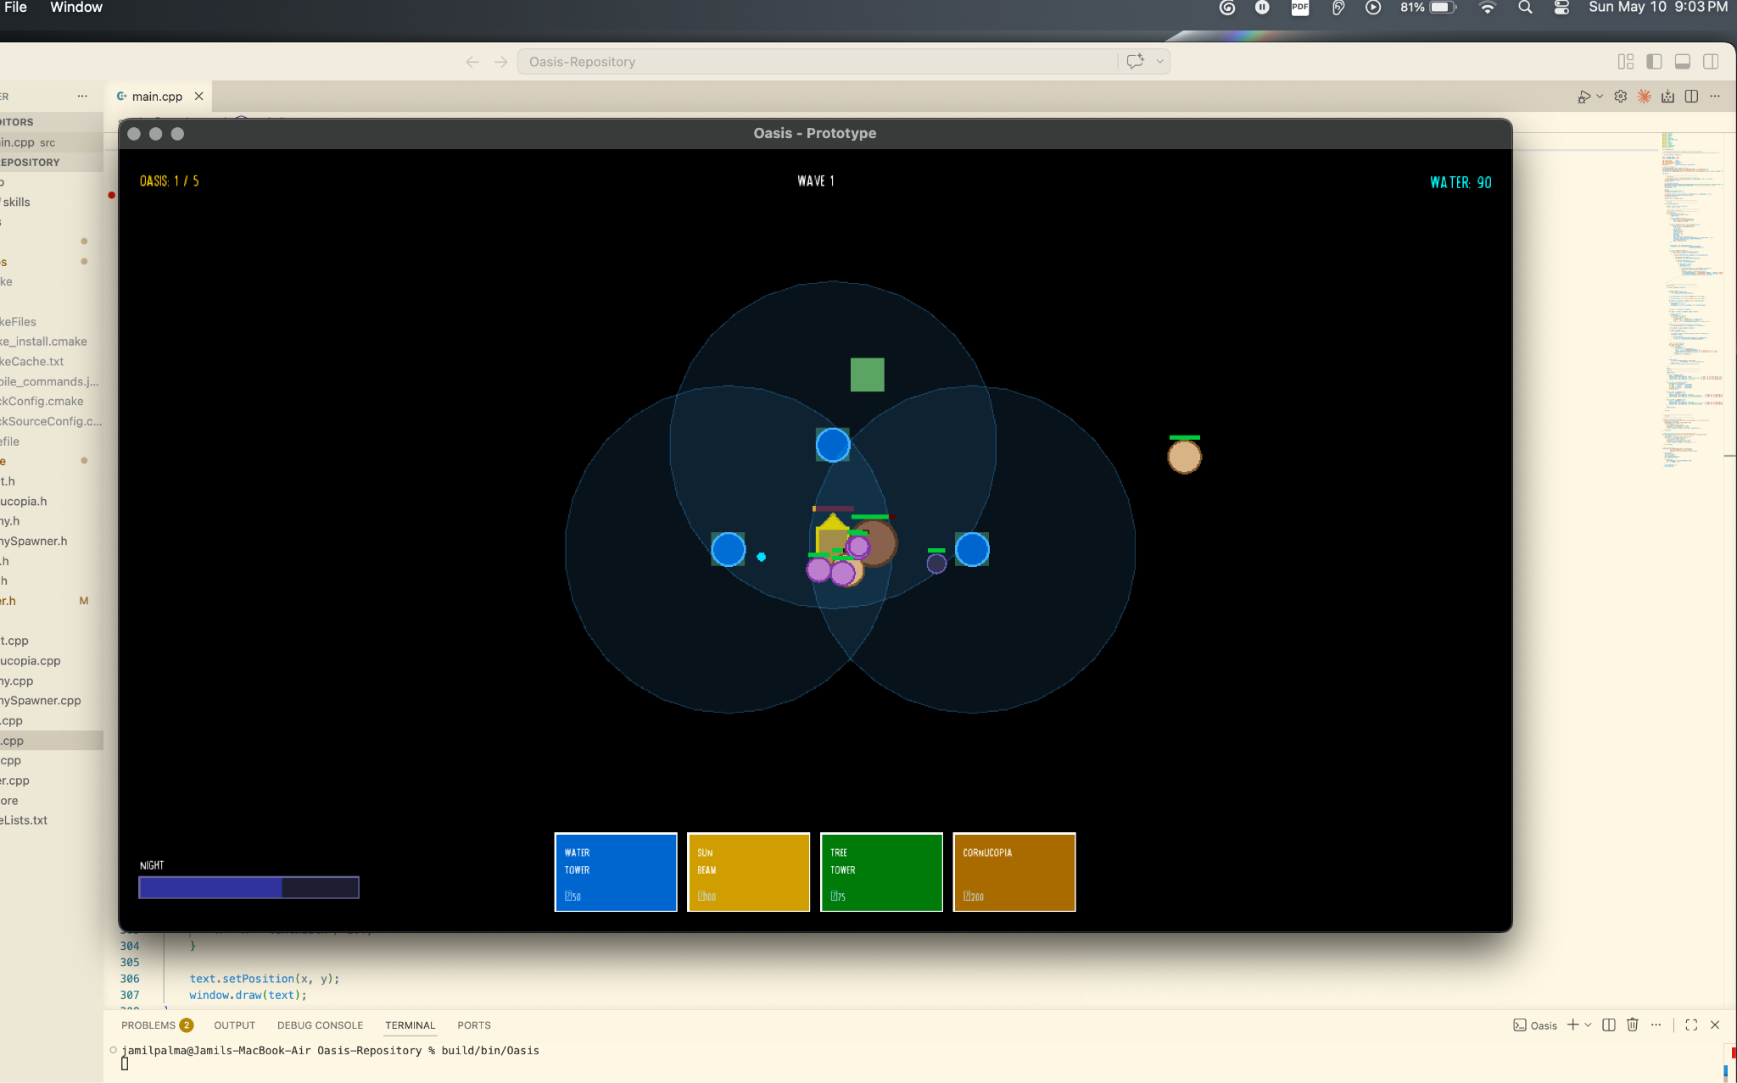

May 11: Cmake + SFML Compatibility Issues
- FIXING SFML 2.6.1 and CMake cross platform issues

- Started with Cj’s laptop:

- So what I did was, clone the SFML Cmake template repo https://github.com/SFML/cmake-sfml-project and followed the steps to make sure that SFML 2.6.1 can actually run on the laptop. It worked and rendered a green circle.

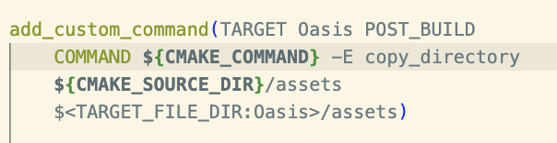
- Now that I know that it runs, I cloned our project repo https://github.com/jams385/Oasis-Repository and adjusted the CMake file to follow the one in the official template and include our src folder (.cpp files) and our include folder (.h files).
- I had problems with outputting text files and apparently it was a problem with the compiling. So I added the function on the right and it works now. (This came from the internet and I only have a slight idea of how it works)
- Then we run these commands in the terminal (making sure that the current directory is “Oasis-Repository”):
Cmake --B build
wait a couple of minutes, then
Cmake --build build
wait a couple of minutes again, then
.\build\bin\Debug\Oasis.exe
the command above runs the code

May 12: Finishing Tower Adjustments
- Make Sun Beam Tower
- Make Tree Tower

- Make Vine Burst Tower

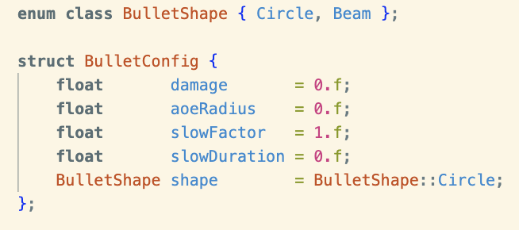

- The code is getting a bit confusing and jumbled especially since we’ll be introducing new bullet types. But we don’t really have a way to differentiate the bullets and a lot of it is hard coded. So what I did was make a new class for bullet configuration in bullet.h.
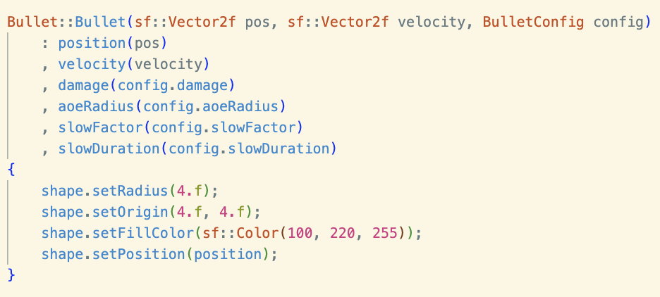
- With this, we can now adjust the characteristics of the bullets.

- This also allows us to add new bullet characteristics without crowding the parameters of the constructor Bullet() in bullet.cpp
- You’ll see how we can adjust the bullet configuration based on the tower type next.

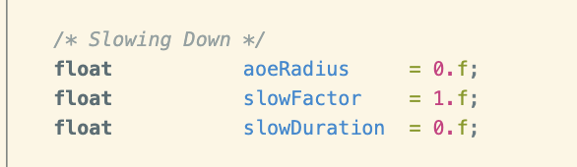
TOWER.H
- We add these new variables for the tree tower.

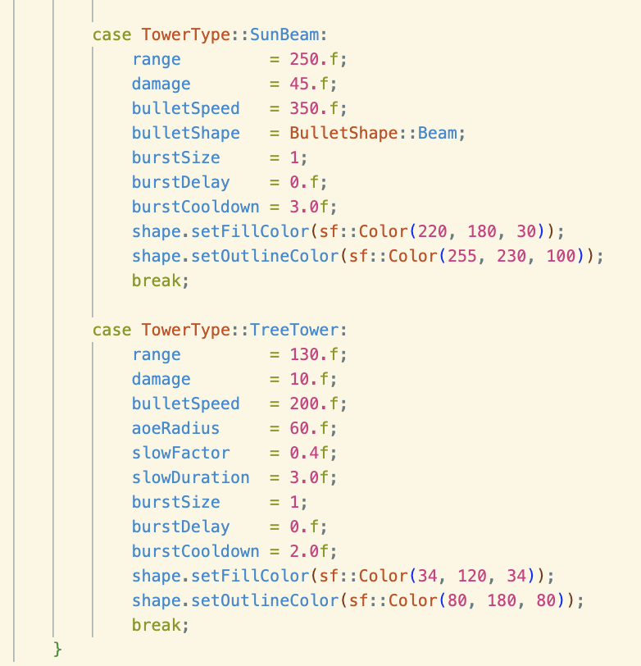
TOWER.CPP

- Let’s initialize the stats of the two towers: SunBeam and TreeTower.

- Some notable variables:
  - bulletShape::Beam- came from bullet.h and just changes the shape from the default circle into a beam.

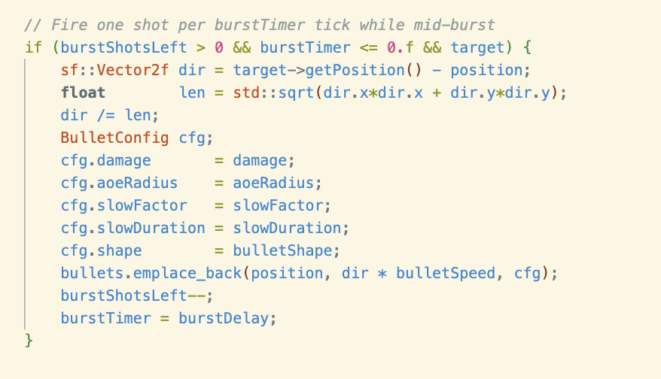

- Next, we adjusted the update() function in tower.cpp to use the BulletConfig class. Now, the bullet characteristics are unique per tower.

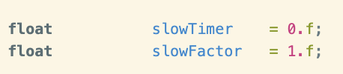
Enemy.H and Enemy.cpp
- In Enemy.h, add slowTimer and slowFactor. This will make it so we get adjustable values for slowing the enemies.
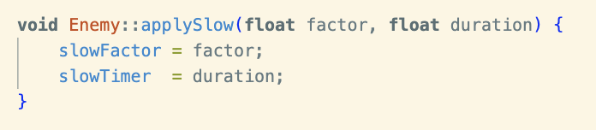
- applySlow just adjusts the variables on top when called.

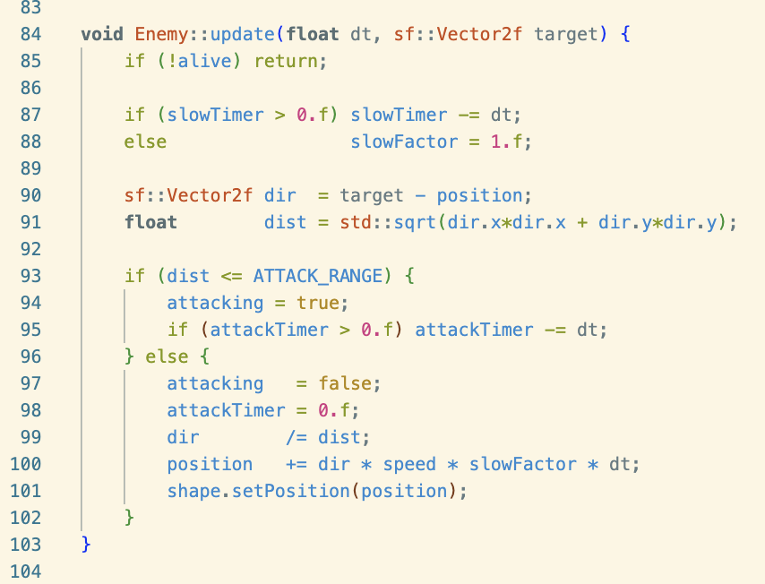
- Then, we revamp the update() function to check if we should slow the target and by how much.
- Logic:
  - applySlow() gets called > slowFactor and slowtimer gains new values > update() gets called > slowTimer starts winding down and slowFactor multiplies the position.

- Math:
  - slowFactor is set to 1 by default because multiplying anything by 1 gets you the same answer. When you multiply by something that is less than one, you reduce the product. In this case we add slowFactor into the equation to reduce position, creating the “slowing” effect.

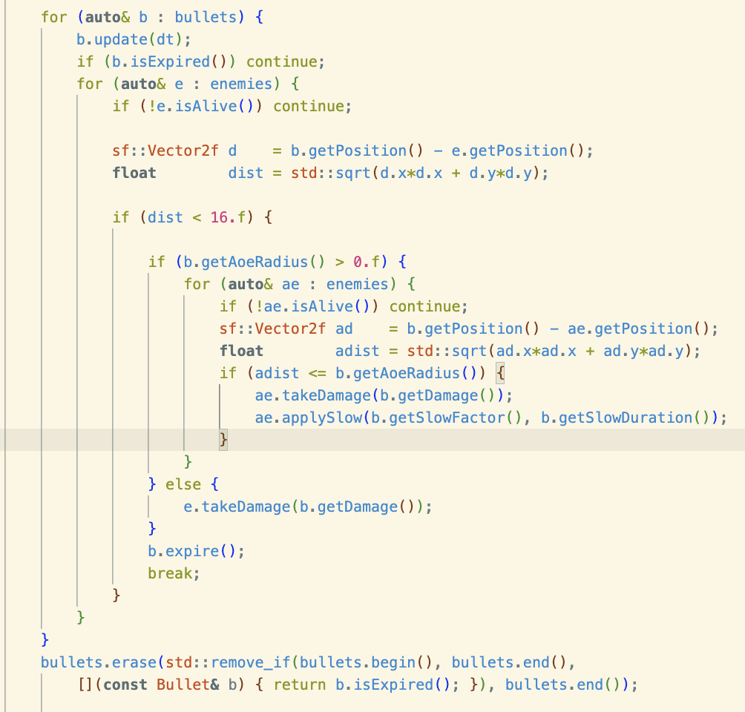
Main.cpp

- Before, we just had e.takeDamage(b.getDamage()) for collision checking. Now we also have to account for AOE splash damage.

- We write a very similar code to how we make the towers target enemies.
  - We first make a for loop to cycle through all enemies.
  - Next, We then check if it’s alive.
  - If yes, we get the direction and distance of the position of the enemy to the bullet.
  - Then, we check if the distance that we got is within the AoeRadius.
  - If yes, that enemy takes damage and the slow effect is applied.

May 21: Cleaning up Code

CODE CLEANUP

TOWER IMPLEMENTATION CLEANUP

- add Cornucopia to class TowerType

- Make Tower::getCost(). This makes it much easier to adjust and create new towers because the towers’ cost was previously hard coded in HUD.cpp which is confusing and unnecessarily complicated.
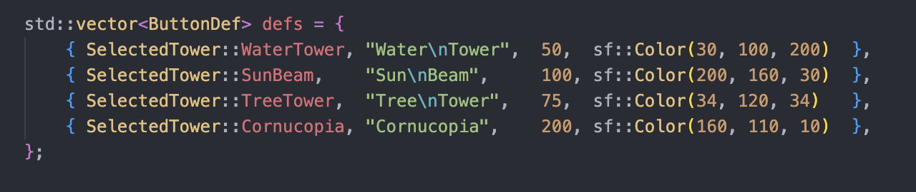
  - Here’s the code where the costs “50, 100, 75, and 200” are hard coded into the individual towers.
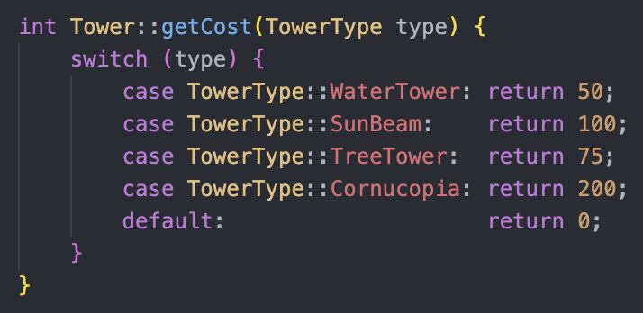
- Here’s the new function that receives the tower type and returns its cost.

- update HUD.c and HUD.cpp to use the new logic
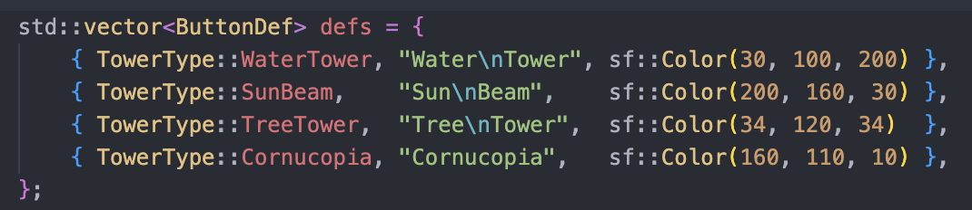

- It already uses it, but now cost is already part of the tower type so we just remove it.

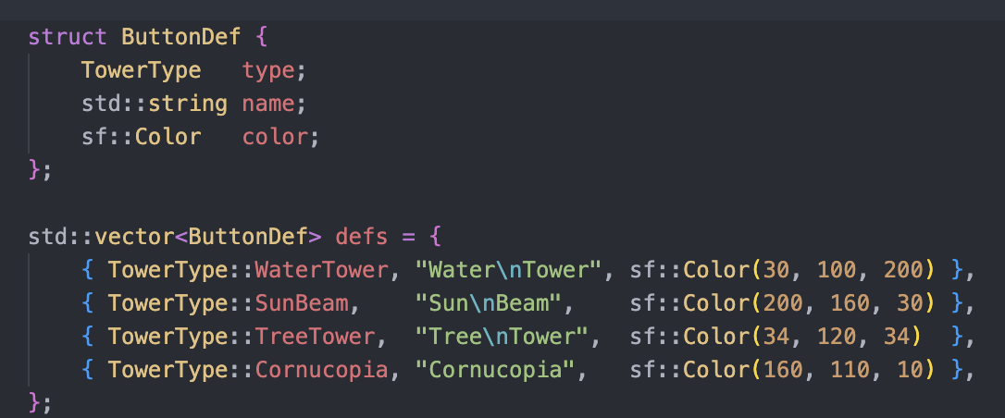

- Here’s the change we made in hud.cpp where instead of SelectedTower, we now use TowerType from tower.h.
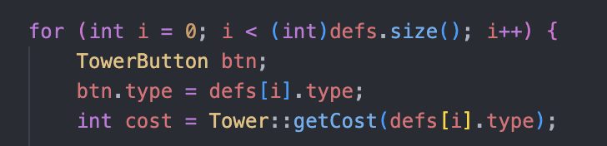
- Next, we create an int variable, cost, to hold the value returned by Tower::getCost().

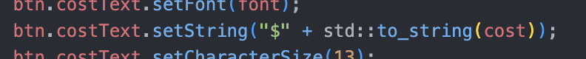
- Then it is converted to string and is printed to the button.

- Now to add a tower here’s what you’ll have to do (flow):
  - Add to towerType in tower.h.
  - Add its stats and cost in tower.cpp.
    - Found in initStats() and getCost()
  - Add to a button for it in HUD.cpp
    - Found in buildButtons()

MAIN.CPP CLEANUP

- Main has become cluttered and messy. Comparing this to other sfml game projects in github like: https://github.com/mataktelis/Simple-SFML-2D-Game/blob/master/src/Main.cpp is embarrassing and makes me think that there should be a better way to go on about this.

- To clean up main.cpp, we’ll implement a game.cpp in our project that manages the game loop: Event -> Update -> Render

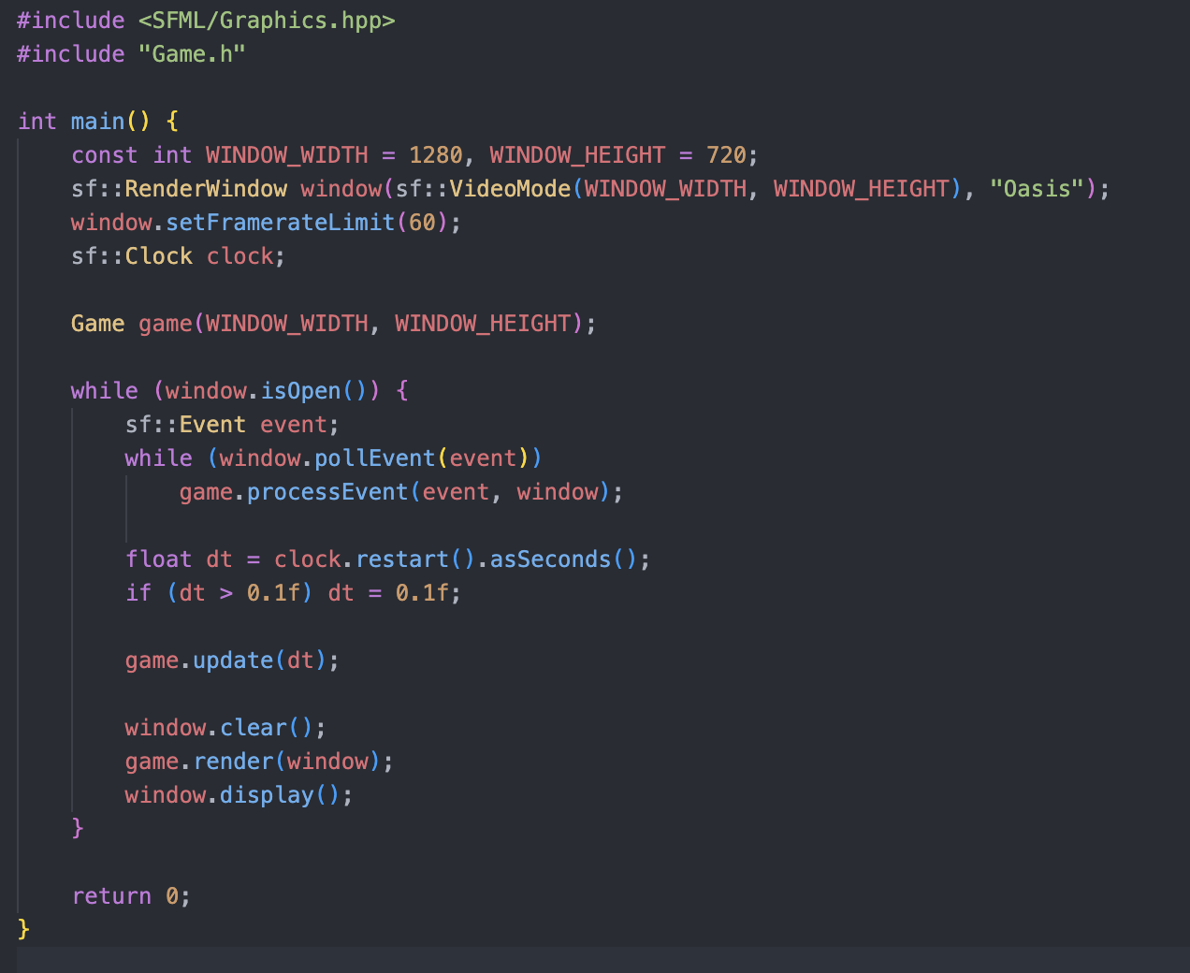

- Main.cpp now only handles the initialization of the window config (resolution, framerate);
- Game game(WINDOW_WIDTH, WINDOW_HEIGHT);
  - calls game() from “Game.h” which starts the whole game logic.
- While loop to cycle through updates.
- Another loop, while(window.pollEvent(event))
  - The loop stops when it returns false meaning there’s no event left.
  - game.processEvent(event, window), which just processes all events into the game.
- game.update(dt), game.render(window)
  - The logic is still the same, the difference is that all we do now is call the update and render function. And the actual code is in game.cpp.

GAME.CPP
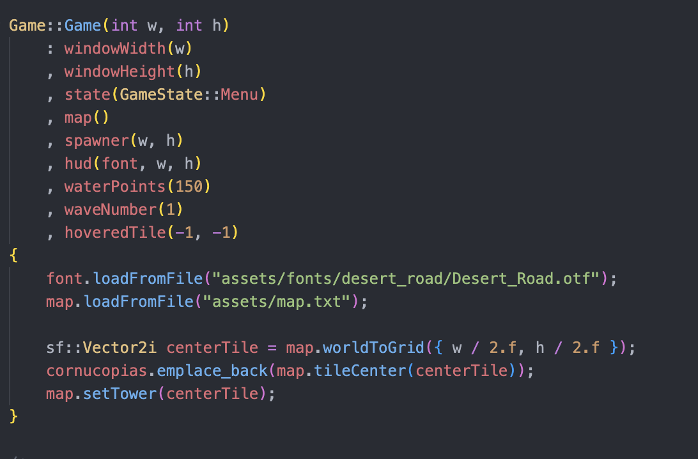
- This is a constructor function and here are the variables it constructs:
  - windowWidth(w), windowHeight(h) - store the window dimensions
  - state(GameState::Menu) - game starts on the menu screen
  - map() — default-constructs the map
  - spawner(w, h) - enemy spawner needs the window size to know where the screen edges are
  - hud(font, w, h)
  - waterPoints(150), waveNumber(1) — starting values
  - hoveredTile(-1, -1) - off-screen means no tile is hovered yet

- These values are initialized and later used by functions in the Game object.
- Most of the core program is the same. There were problems in using functions like nearestCornucopia() and nearestCornucopiaIndex() because they accessed global variables in main. To fix this,

May 26: New Features and Big Changes
- Pause Menu
- Settings Menu
- Window Fullscreen
- Minimal Camera Movement
- Fix Wave Announcement
- Announcement should appear during the night
- Enemy Number increases per wave.
- Water Points Collecting Tower (Mine)
- Destructable Tower
  - Handle tile with destroyed tower

- Heal Towers
- Enemy Kills towers
- Add boss enemies that pathfinds towards cornucopias

- Sell Tower Feature (gets 70% of cost back)

- Add sound effects

- Cornucopia logic changes
  - Two states: Broken and Active
  - Restore cornucopia
  - Cornucopia win/lose conditions
  - Randomized but controlled spawns for cornucopia

Enemy # increases as wave increases
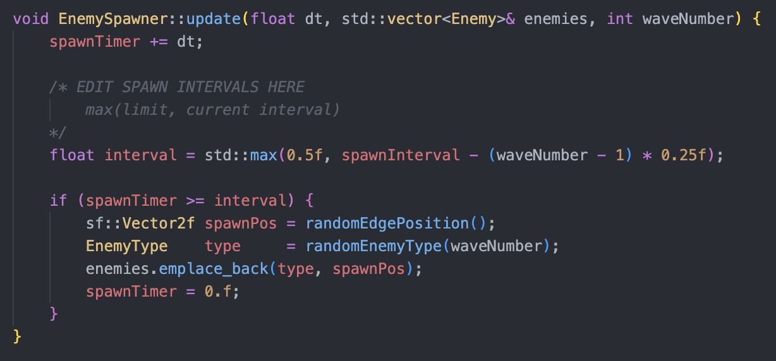

- To do this, I simply added another interval variable and used the max() function from the algorithm library. This function returns the higher number and in this case we use it to set a limit of 0.5f

IMPLEMENTING WATER MINE

- The water mine isn’t really a “defense” tower like the ones in tower.cpp. So similar to the cornucopia, I created a separate class for it.

General Flow

- Tracks time using harvestTimer (which counts up every frame) -> harvestTimer reaches harvestInterval -> ready = true -> if ready is true, it draws an “!” -> collect() gives water points and resets harvestTimer.

WaterMine.h and WaterMine.cpp
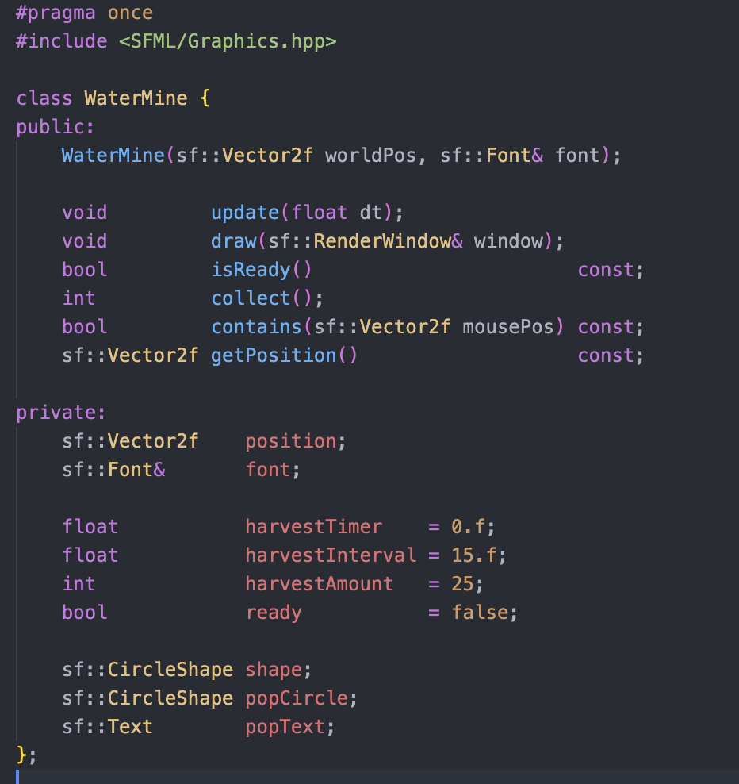

- Here are the public methods and private variables that the class WaterMine can use.

- More info on them as we talk about WaterMine.cpp.
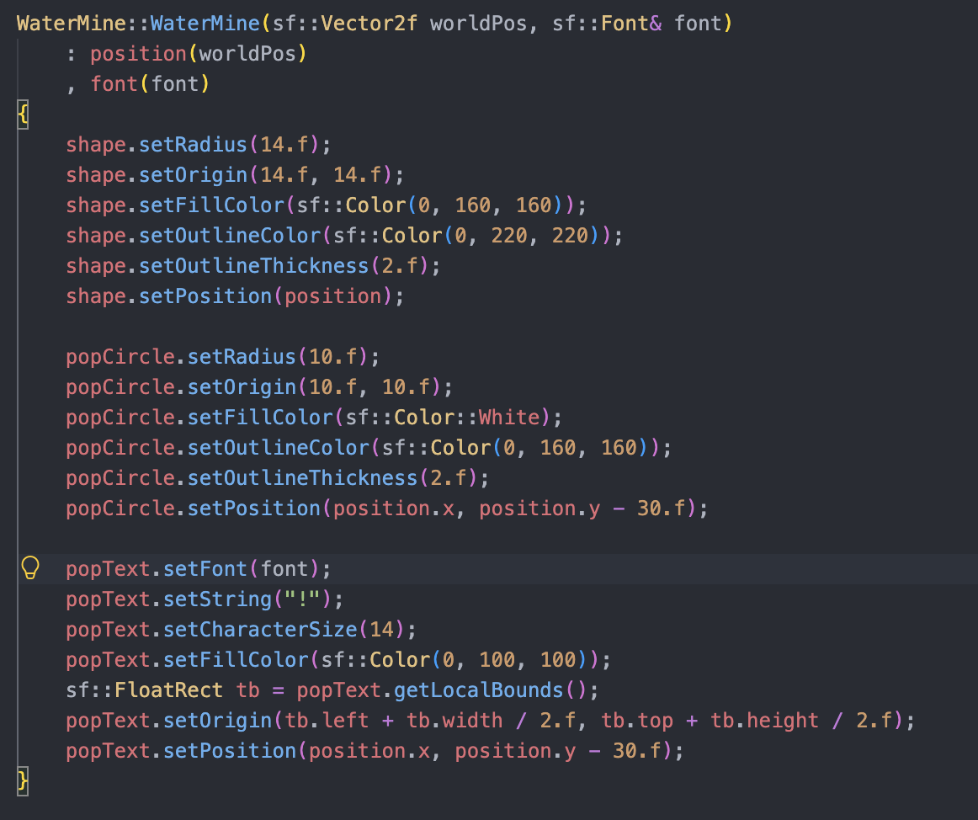
Here’s our constructor function: WaterMine()

- It takes two parameters:
  - worldPos - coordinate on screen where the mine is placed.
  - Font - accesses the game’s font to render “!”.
- Then we store the values of these two parameters into the class values: position and font.
- Then the body just sets up the shape of the waterMine.
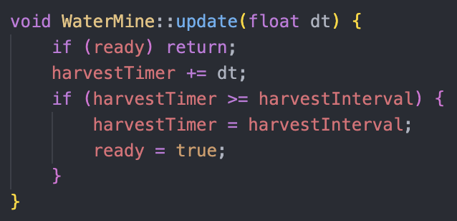
WaterMine: update()

- This is the update function for the WaterMine.
- if ready = true, exit the function. ready is just a way for the program to know if water points are ready to be collected.
- harvestTimer += dt, is a countdown for the timer.
- Once the timer reaches harvestInterval it will make ready true.
  - harvestTimer = harvestInterval is placed as a way for harvestTimer to not exceed the interval in the case where lag spikes occur.

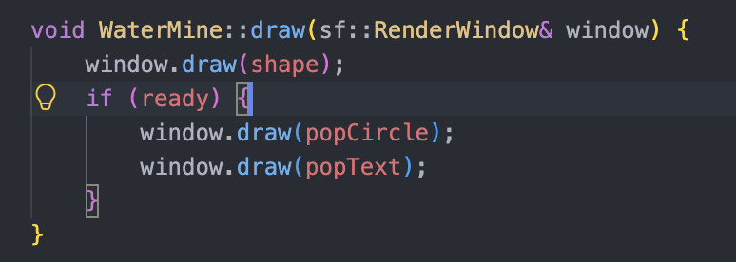

WaterMine:: draw()

- This function draws the circles into the window.
- First it draws the shape (which was initialized in the constructor function)
- Then, when ready is true, it draws the “!” pop up (also initialized in the constructor function)

- Here are some boolean and helper functions.

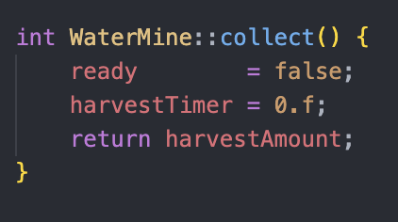
WaterMine::collect()

- This function is called once the player collects the water points from the tower.
- it makes ready = false, resets the harvestTimer, and returns the harvestAmount which gives the water points to the player.

Changes to Tower.h and Tower.cpp

- Added WaterMine to the enum class TowerType which is used by hud.cpp and game.cpp.

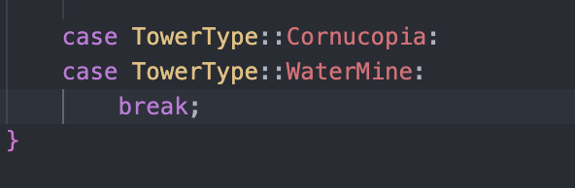
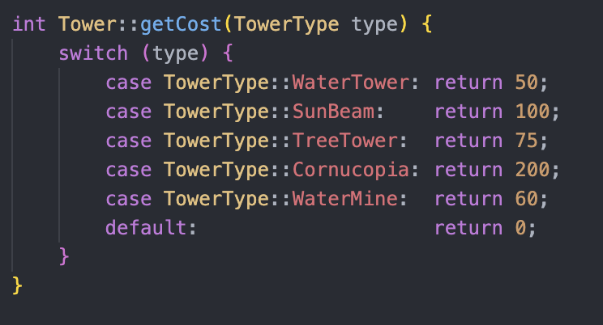

- added the WaterMine to getCost() function which returns its price which is 60.
- In initStats(), I added WaterMine as one of the cases and broke it.
  - The WaterMine is already constructed using its own function. This was only done so that an error wouldn’t appear.

Changes to Game.h and Game.cpp

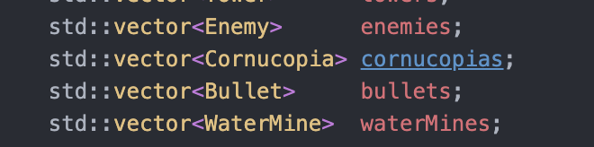

- In Game.h we just added the vector WaterMines, which stores the data of every water mine in the game.

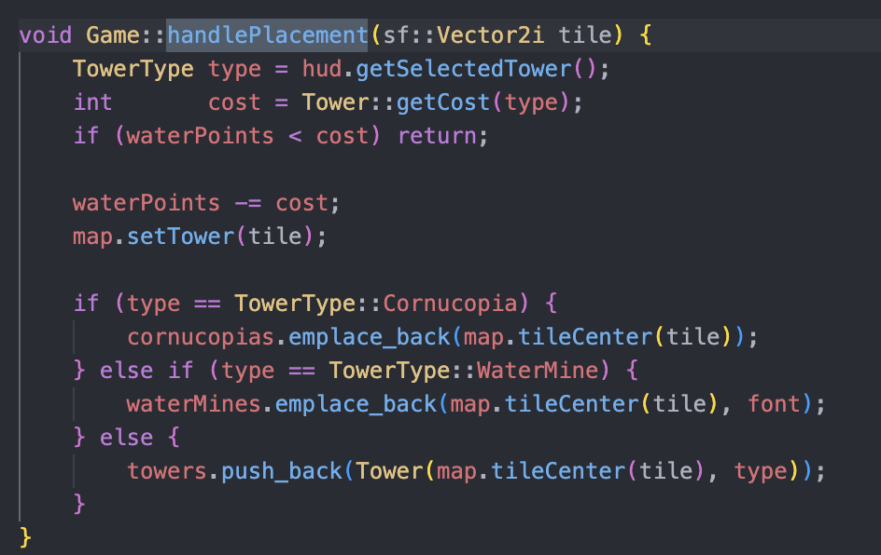
handlePlacement()
- Added an else if statement similar to how cornucopia was handled.
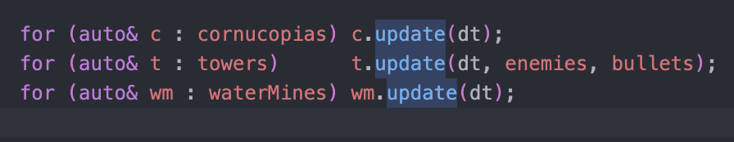
- In the update part of our game.cpp, we added wm.update(dt) in a for loop.
  - This just updates every waterMine in the vector.

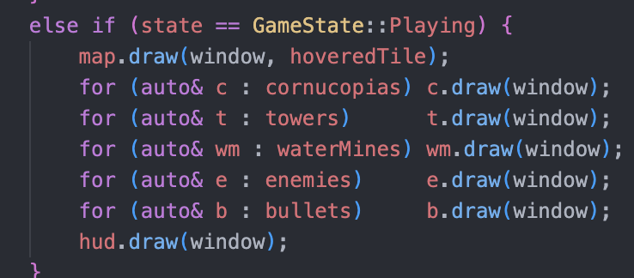

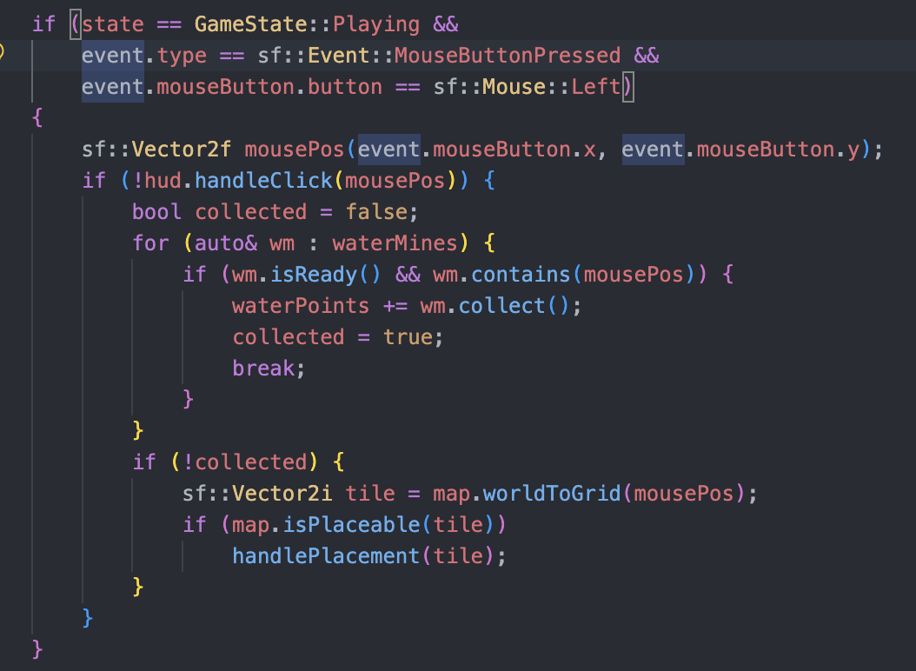
- We do the same thing for when we render.

- We add a condition for when the click will actually do something. Conditions: gamestate is playing, mouse is pressed, and the pressed key is the left mouse button.

- Next we get the coordinates of the mouse position. First, we make sure that the hud gets first priority. We do this by using an if statement and making sure that hud.handleclick() is false before continuing.

- Next we loop through every water mine in the vector. We do this to check for 2 things.
  - wm.isready() - to check if the water mine is ready for collection.
  - wm.contains(mousePost) - to check if the mouse click landed on the mine’s position.
- If these conditions are met, wm.collect() runs and adds the water points to the player’s balance. Then collected is given the true value.

- Now, if no water mine was collected, it converts the pixel position into a Vector2i tile (which is the grid coordinates) and then handles placement.
  - If this is not here, instances where players might want to collect might overlap with creating a structure.
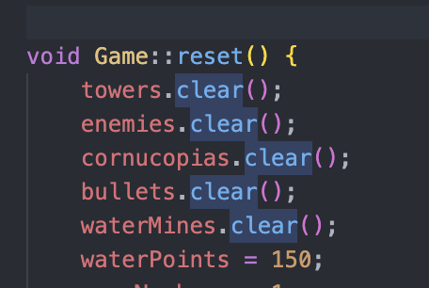

- Added waterMines.clear() to the reset() function. This is used for updating and re-rendering.

IMPLEMENTING TOWER HEALTH

Tower.cpp and WaterMine.cpp
- Remember how we implemented a health bar for cornucopia? What we did for the towers and water mine is very similar.

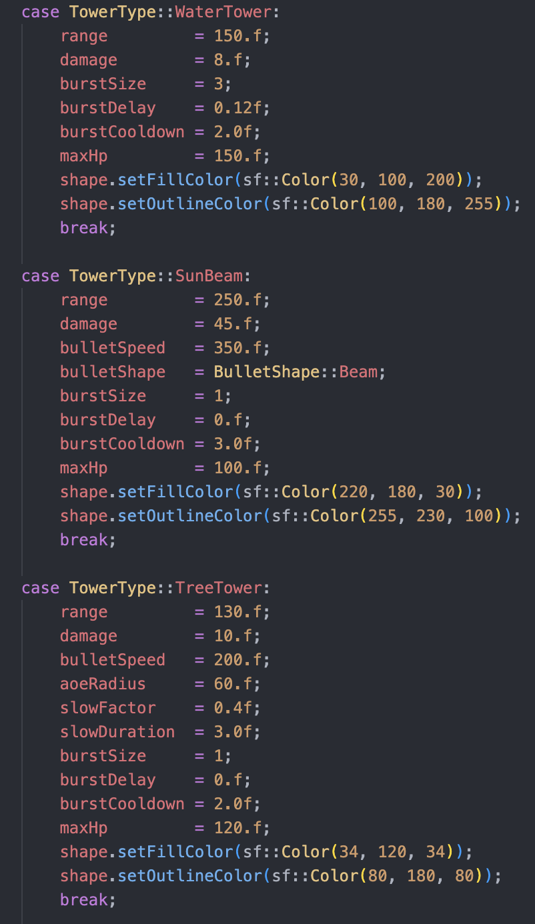

- Each tower type in initStats() has a maxHp variable that serves as the tower’s starting health.
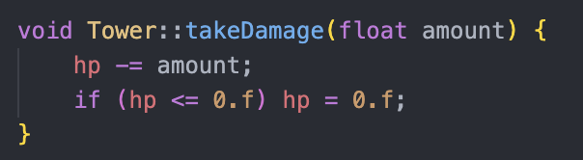

- takeDamage(), is a function called to decrease the hp of the structure.
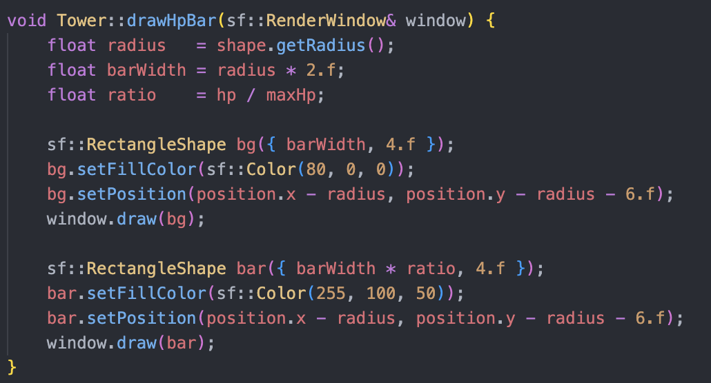

- drawHpBar() draws the shape of the hp bar: one for the max hp and one for the current hp which is laid on top.
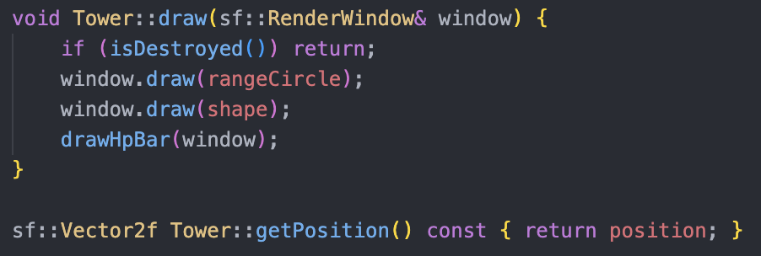
- We use the variables: radius, barWidth, and ratio to change the size of the “current hp” bar.
- draw() now draws the hp bar by calling drawHpBar().

Implementation of enemy targeting for towers and water mines

- We had nearestCornucopiaPos() and nearestCornucopiaIdx() as functions that handled the enemy targeting.

- We just changed those so that now it will include the other structures when checking.
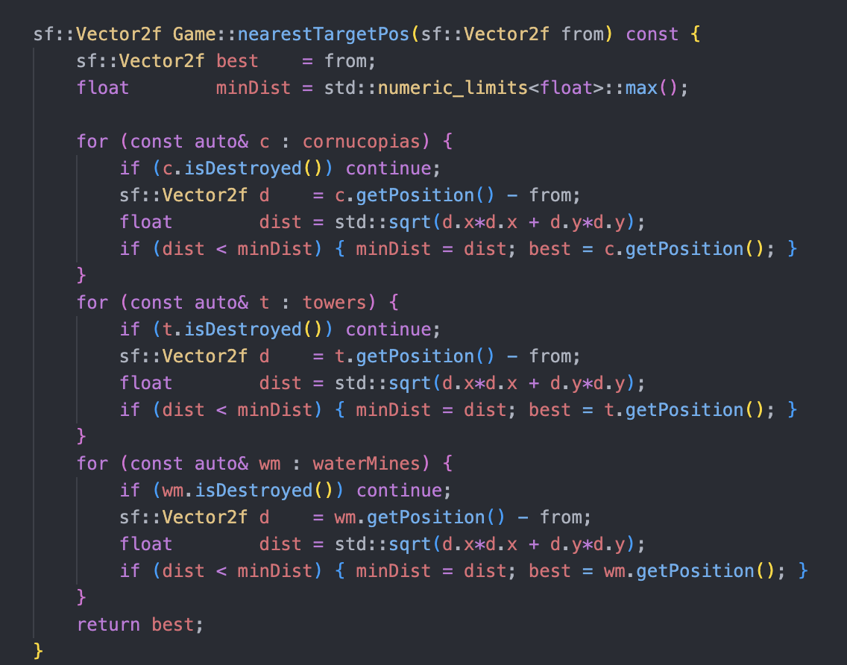

- Here we use a for loop to check every tower and then we check which structure is closest. This info is stored at best. After checking each structure the position of the final structure assigned to best is returned.

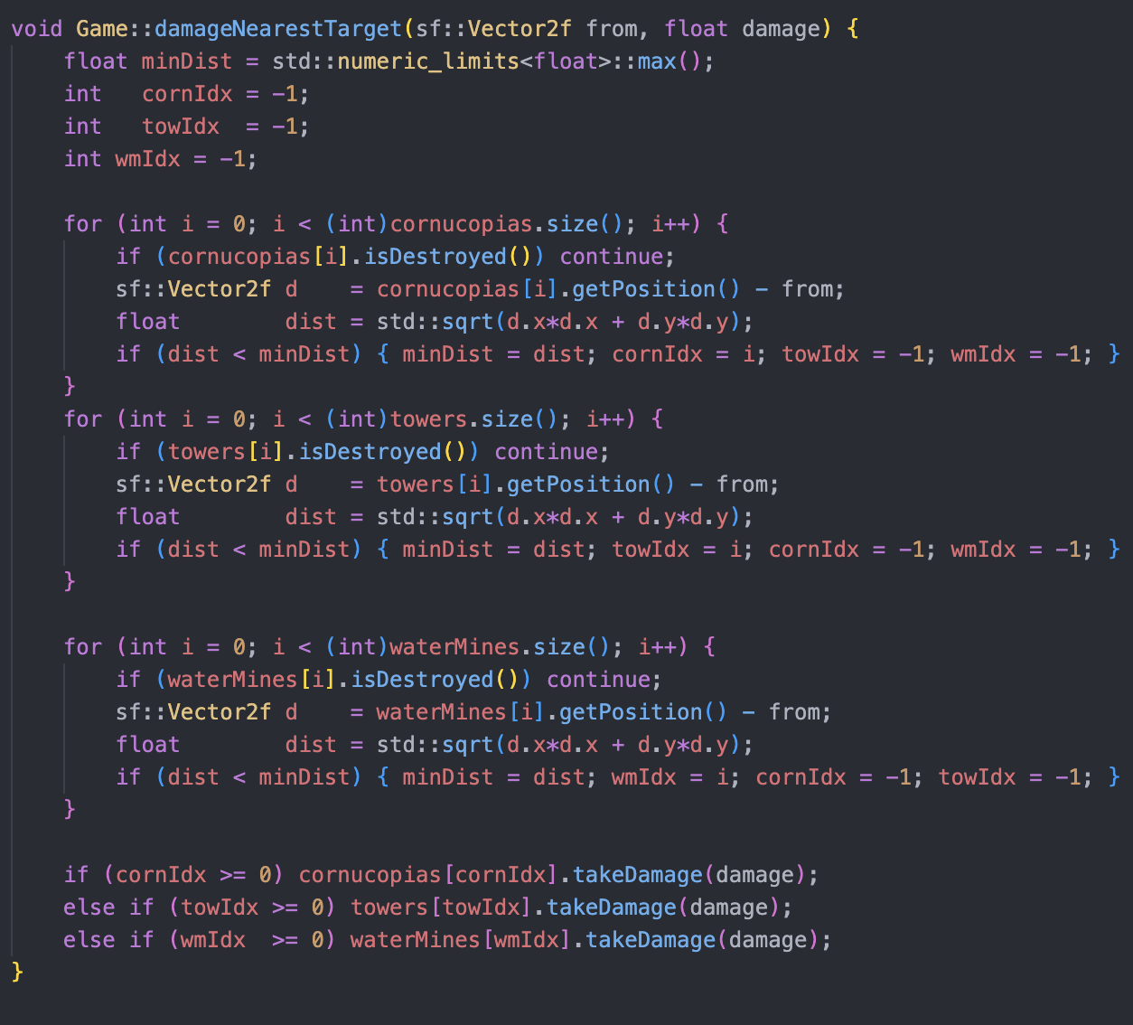

- This function uses a similar pattern to the previous function. This time we check for the nearest structure and then assign it with the value of “i” which is the index of the current tower in the vector.

- Then we use if statements and the takeDamage functions of each class to reduce the health of the structure.
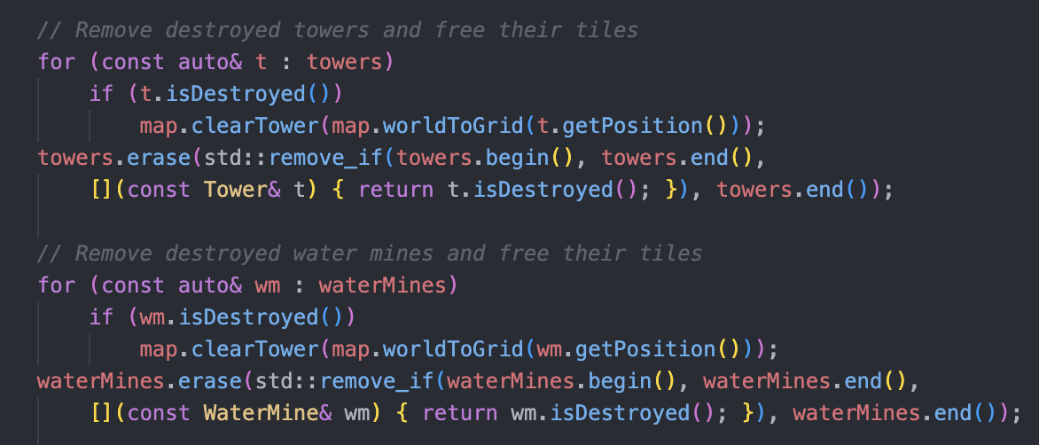

- In the update part of game.cpp, we check for destroyed towers and waterMines. We do this by looping through the respective vectors and clearing them through the clearTower() method of the map class.

CORNUCOPIA CHANGES

Creating Broken and Active states for Cornucopia
- Now, cornucopia has two states, Broken and Active, which is assigned to cornState.
- cornState is of class CornucopiaState which is where Broken and Active is.
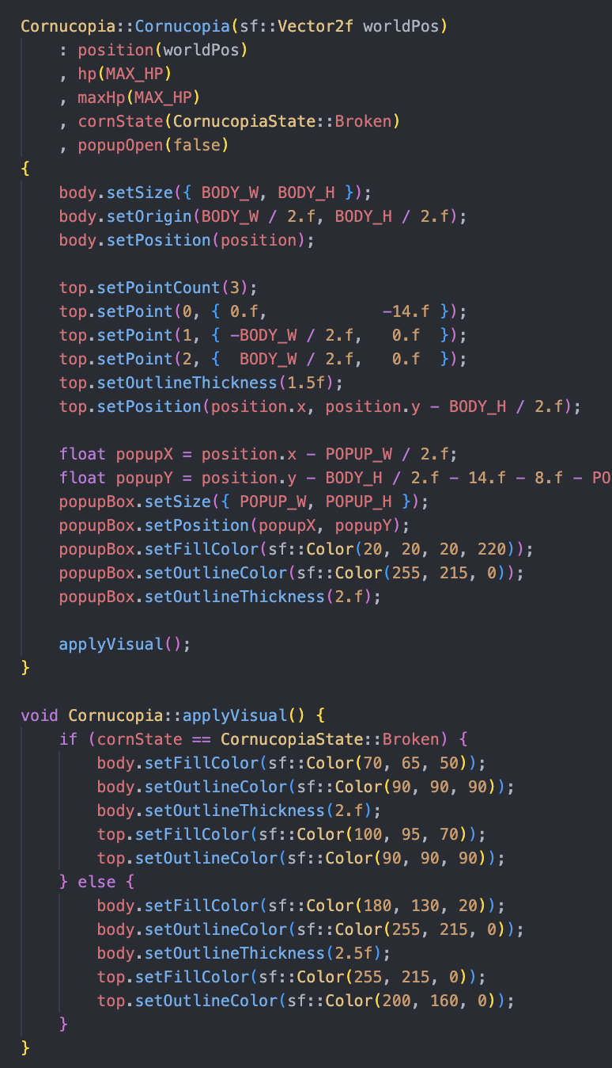
- The constructor now initializes cornState and popupOpen.

- The function body is still the same but now we create the shape of the popup.

- We also run applyVisual(). This just initializes the shape of the broken cornucopia.
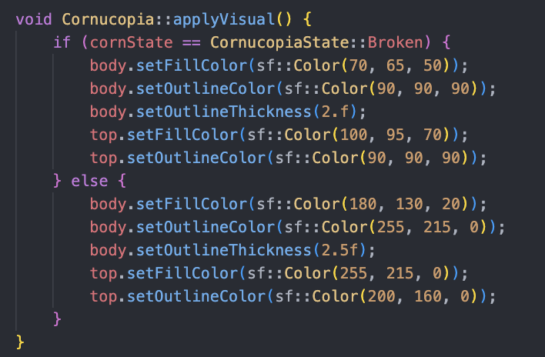

Spawning Cornucopias in the map

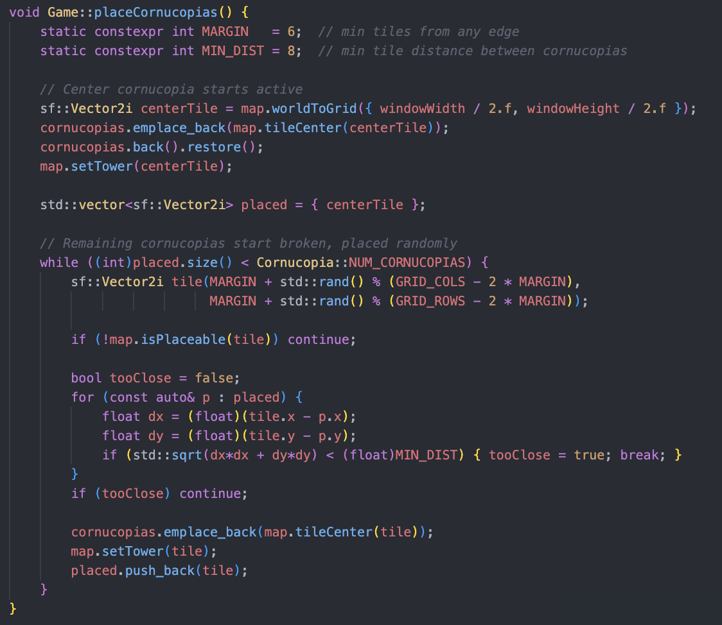

First, we create two static constants: MARGIN and MIN_DIST. MARGIN represents how many tiles away from the edge a cornucopia can spawn. MIN_DIST represents the minimum tile distance between two cornucopias. This will make sure that when positions are randomized, we won’t get cornucopias positioned near the edge or near each other.

- We made it constant so that it can be easily adjustable once we try to balance it.

Next, we place the center cornucopia which always starts active. We do this by getting the centerTile. Then we place that cornucopia into the cornucopia vector, access the cornucopia using back(), and then call restore() to make it Active.

- Restore() is a method from cornucopia.h. Will be discussed later.

We then have a vector named “placed” with the type Vector2i to assign the position of the cornucopias. This is used for comparison with MIN_DIST.

Then we place the remaining broken cornucopias. First, there’s the loop condition. The condition is that the size of the vector must not exceed the public variable NUM_CORNUCOPIAS of the Cornucopia class. This makes it so it’s easily editable.

For the loop, we find a random tile within the MARGIN that we set. If the place is not placeable in that tile we find a new tile. Then we check if the tile is too close to any of the other cornucopias. If so too close becomes true and we find a new tile.
If all of those are satisfied, a cornucopia is placed in the cornucopias vector, map.setTower(tile) is ran changing that tile to be “occupied” in the map, then the coordinates of the tile is inserted to the vector which is used for comparing the next cornucopia.

Restoring Cornucopia
The general flow is that: click a broken cornucopia -> pop up appears -> click restore to restore -> make sure you have enough money -> restored.

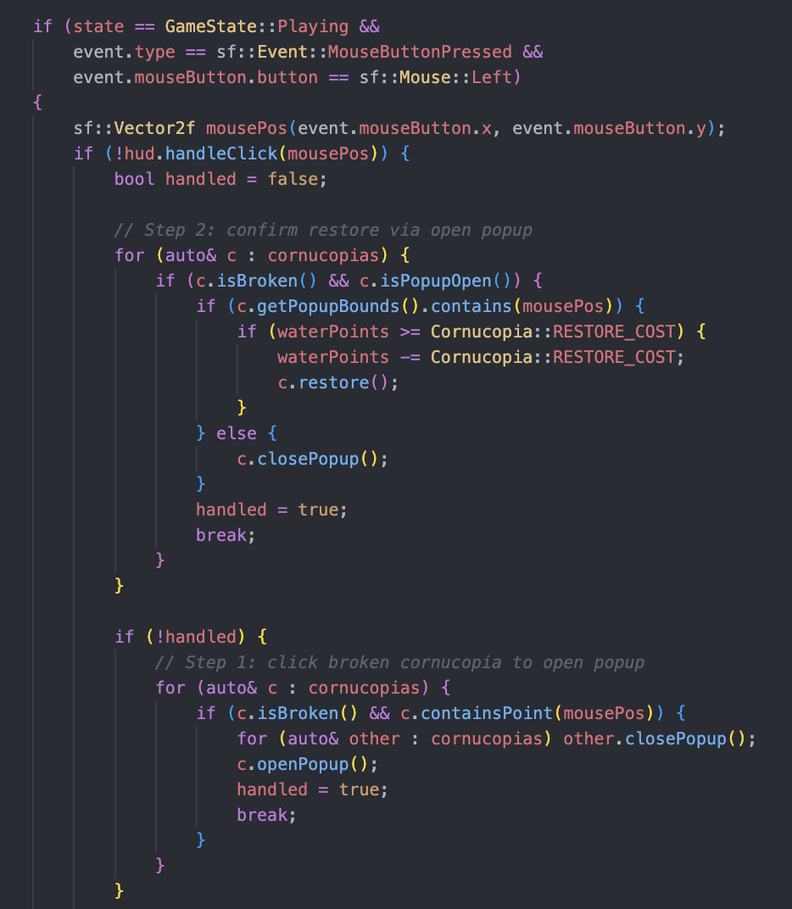

First, check if the click is for the hud (again, hud is the priority). Then we initialize a value handled which just makes sure that once our action does something it won’t try to run other things. For example, when we click on a cornucopia we want to make sure that we aren’t trying to place another tower or something.

Next, we loop through every cornucopia. If a cornucopia isBroken and and if the coordinates of the mouse click is on top of the cornucopia then it will return true. Below is the body of containsPoint() from the Cornucopia class.

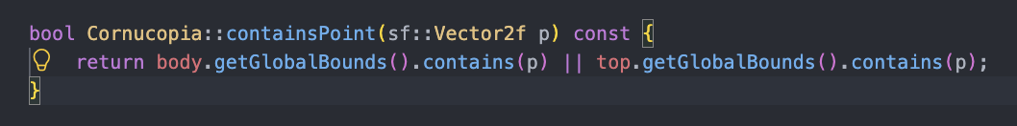

Then we use a for loop to loop through all the cornucopias and close its pop up if it’s open. After, we open the popup of the current cornucopia and make handle = true to signify that the purpose of the mouse click is done.

Notice how we put “step 2” before step 1, this is because step 2 is about clicking the pop up to restore the broken cornucopia. If it doesn’t go first, it is possible for the program to think of a click as just pressing the cornucopia again so instead of restoring it it would just reopen the pop up.

The logic for confirming the restore through the pop up is just very similar to clicking on the broken cornucopia to open the pop up. Except for the restore() method of class Cornucopia.

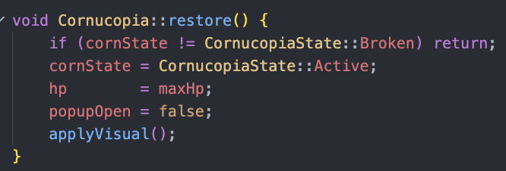

The restore() method just changes the cornucopia state to Active, hp to 100%, and makes popupOpen false which makes it so that pressing the active tower won’t activate a pop up.

Win/Lose Condition
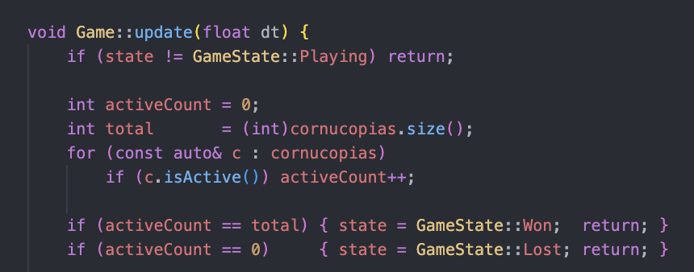

At the start of every update, we check if the player has won or lost. We do this by initializing the activeCount (counter for active cornucopias) and incrementing 1 for every active cornucopia in the vector.

Then we use an if statement to check if the total cornucopias is reached or if the count is 0. This changes the GameState into won or lost, respectively.

Enemy Behavior
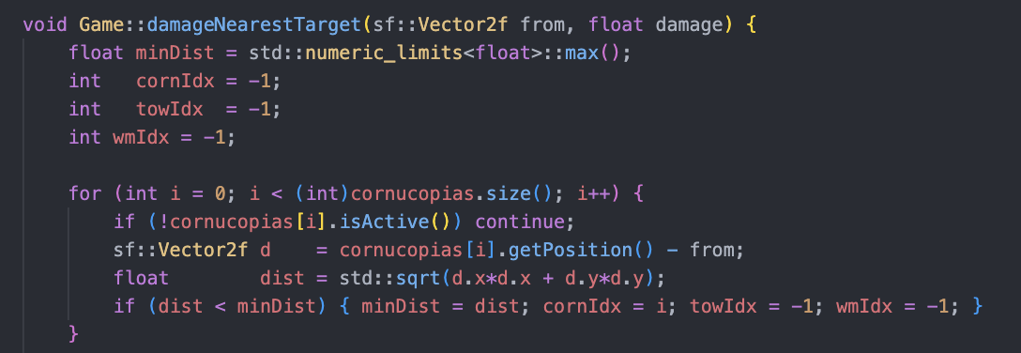

For both damageNearestTarget(), nearestTargetPos() we just added an if statement for when cornucopia is broken or when isActive == false. This is so the enemy won’t target a broken cornucopia.

HUD Changes
First, we removed the cornucopia button. Then the update() method receives int restoredCount (count of active cornucopias) and int totalCornucopias (total cornucopias needed to win)

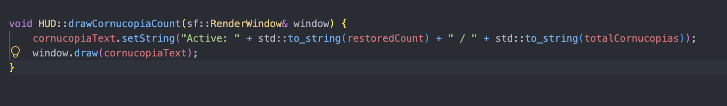

We now have a draw function for the CornucopiaCount(). Which just uses setString and cornucopiaText to draw how many are restored and the total needed to win.

May 27: Final Few Days
- Pause Menu
- Settings Menu
- Window Fullscreen
- Minimal Camera Movement
- Fix Wave Announcement
- Announcement should appear during the night
- Enemy Number increases per wave.
- Water Points Collecting Tower (Mine)
- Destructable Tower
  - Handle tile with destroyed tower

- Heal Towers
- Enemy Kills towers
- Add boss enemies that pathfinds towards cornucopias

- Sell Tower Feature (gets 70% of cost back)

- Add Sound Manager

- Cornucopia logic changes
  - Two states: Broken and Active
  - Restore cornucopia
  - Cornucopia win/lose conditions
  - Randomized but controlled spawns for cornucopia

- Sprite Manager

Passive Healing for the structures

General Flow for Tower.cpp, WaterMine.cpp, Cornucopia.cpp
- Added constant variables HEAL_DELAY and HEAL_RATE before their respective update() methods.

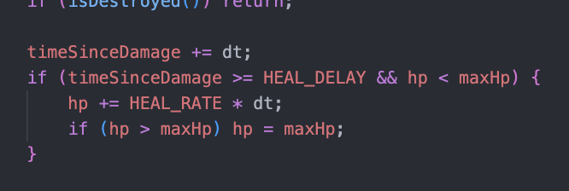

- Then we add this logic into the update() methods.
- This just starts a timer named timeSinceDamage, if this timer is greater than the HEAL_DELAY then enough time has passed. Before adding hp, we also check if hp is actually less than the maxHp.

Add sound effects

END OF DOCUMENTATION

Ps. the due date of the final presentation was on May 30. Writing the documentation takes a lot of time and with the deadline approaching and us rushing to deploy the game in a playable state… I was not able to make enough time to update the documentation.

